**Purpose**

To present observations on the 2/25/2015 TEB FSDO FAAST webinar on “Starved and Exhausted! Preventing Fuel Related Accidents.”

To present recommendations on how PHL FSDO FAAST can use webinars as well as how these webinars can be optimized for effectiveness and success.

**Observations and Discussion**

For the first 13 slides, there was a recording indicating that “The webinar will begin shortly. Please remain on the line.”

My sense is that the presenter may have done the following:

* Went to Full Screen Mode on his viewer. This would have minimized his GoTo Webinar control panel.
* Set his GoTo Webinar control panel to use “Telephone” instead of “Mic & Speakers.”

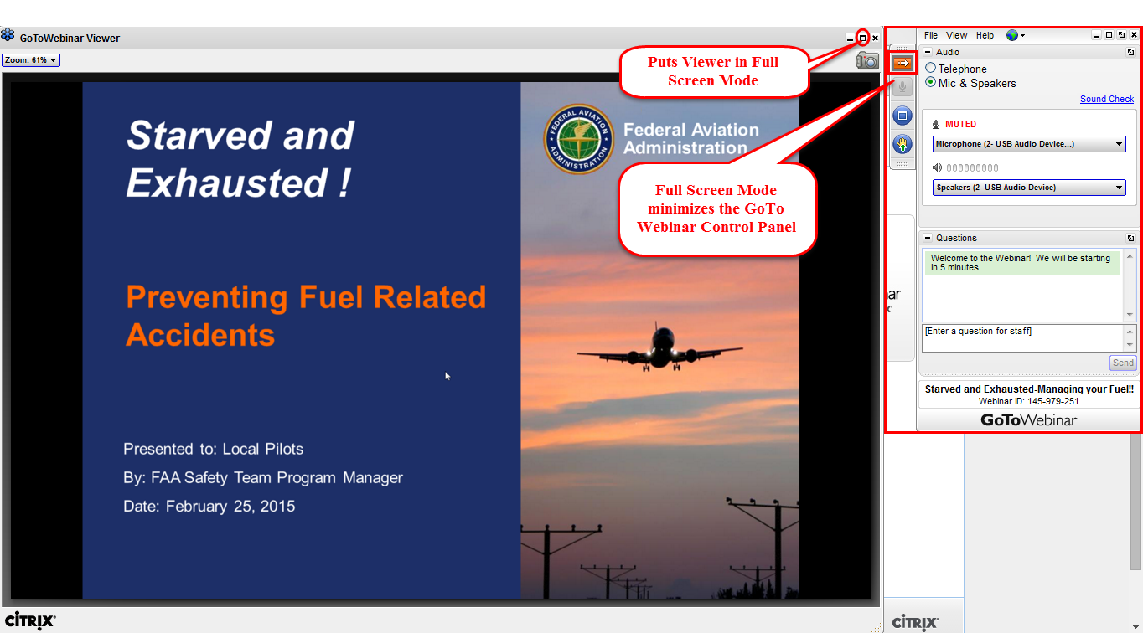

The views below of my GoTo Webinar Control Panel illustrate my attempts to communicate with the presenter via Hand Raised.

The presenter probably did not see this because his display was probably in Full Screen Mode and his GoTo Webinar Control Panel was probably minimized. I also sent a message via the Question Window, but this was probably not seen for the same reason.

|  |  |
| --- | --- |
| **My GoTo Webinar Control Panel  Showing Hand Raised** | **My GoTo Webinar Control Panel  Showing Hand Down** |
|  |  |

Quite often it was difficult to hear the presenter. While I am hearing-impaired, I was wearing a Cyber Acoustics model AC850 USB headset. I was able to hear quite clearly the recording that “The webinar will begin shortly. Please remain on the line.”

My sense is that the presenter was using the integrated microphone on his laptop. Please see the illustration in the Visio schematic below.

I suspect that presenter’s voice volume diminished whenever he turned his head away from the integrated microphone. This latter could have been due to reading from notes.

It is also possible that the presenter used a cell phone to connect to the audio bridge instead of an analog conference phone.

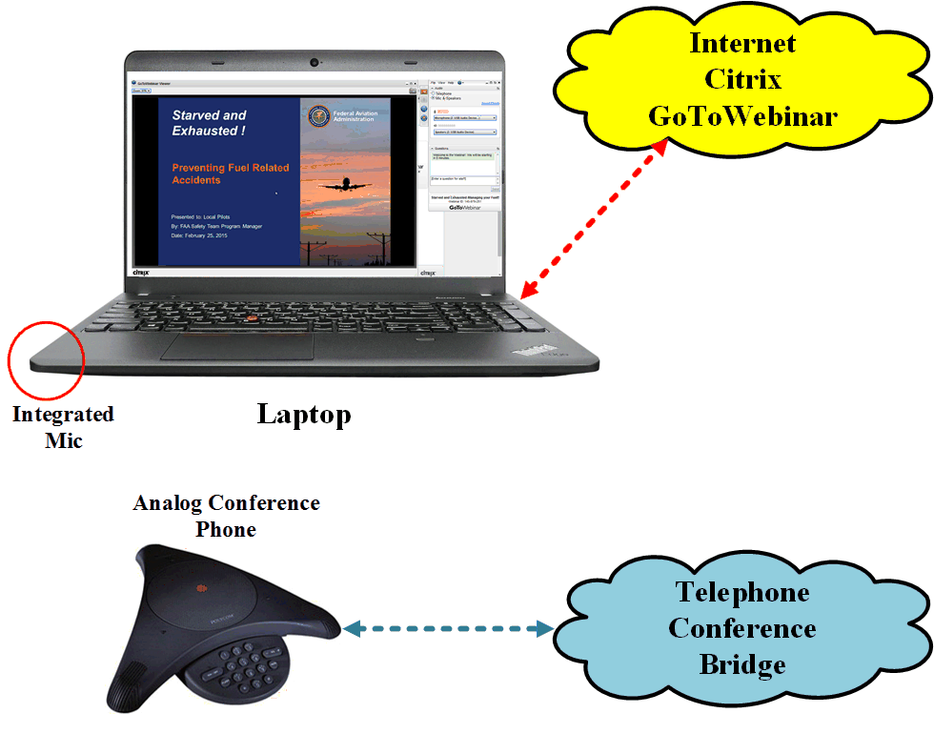

**Recommended Next Steps for PHL FSDO FAAST**

Develop a team approach to webinars for the PHL FSDO FAAST. The team should consist of the following participants, though it is not necessary that they all be located together for the webinar.

* A PHL FSDO FAAST presenter who will have organizer authority in Citrix GoToWebinar and will actually present the webinar. This person will do the following:
  + Make sure that the recording “The webinar will begin shortly. Please remain on the line,” has been turned off and that the presentation has started
  + Make sure that their GoTo Webinar Control Panel is visible and that it has not been minimized by Full Screen Mode for the presentation.
  + Have a USB headset to connect to their laptop to accommodate webinar attendees connecting via “Mic and Speakers.”
  + Have an analog conference phone in place and working to accommodate webinar attendees connecting via “Telephone.”
  + Monitor the Question window of their GoTo Webinar Control Panel to see if anyone is reporting problems. These should be addressed immediately.
  + Monitor the Question window of their GoTo Webinar Control Panel to see if anyone has questions about presentation content. These can be held until break. Just be sure to let the audience know that is how you will handle it.
  + See the next page for a Visio schematic of the presenter’s configuration.
* A PHL FSDO FAAST member who will monitor the webinar from a “Telephone” perspective and provide input to the presenter via either email or text message that
  + Audio on the telephone side is working
  + The presentation is visible from the Internet and moving from slide to slide
  + This person should also make sure that their GoTo Webinar Control Panel is visible and that it has not been minimized by Full Screen Mode for the presentation.
  + This person should use a phone to connect to the voice gateway.
  + Monitor the Question window of their GoTo Webinar Control Panel to see if anyone is reporting problems. Let the presenter know this so the question can be addressed immediately.
* A PHL FSDO FAAST member who will monitor the webinar from a “Mic and Speakers” perspective and provide input to the presenter via either email or text message that
  + Audio on the Internet Mic and Speakers side is working
  + The presentation is visible from the Internet and moving from slide to slide
  + This person should also make sure that their GoTo Webinar Control Panel is visible and that it has not been minimized by Full Screen Mode for the presentation.
  + This person should use a USB headset to connect to their laptop.
  + Monitor the Question window of their GoTo Webinar Control Panel to see if anyone is reporting problems. Let the presenter know this so the question can be addressed immediately.

This Visio schematic illustrates one alternative for the PHL FSDO FAAST presenter’s configuration. This configuration would be useful when two or more FAAST members were at the same location.

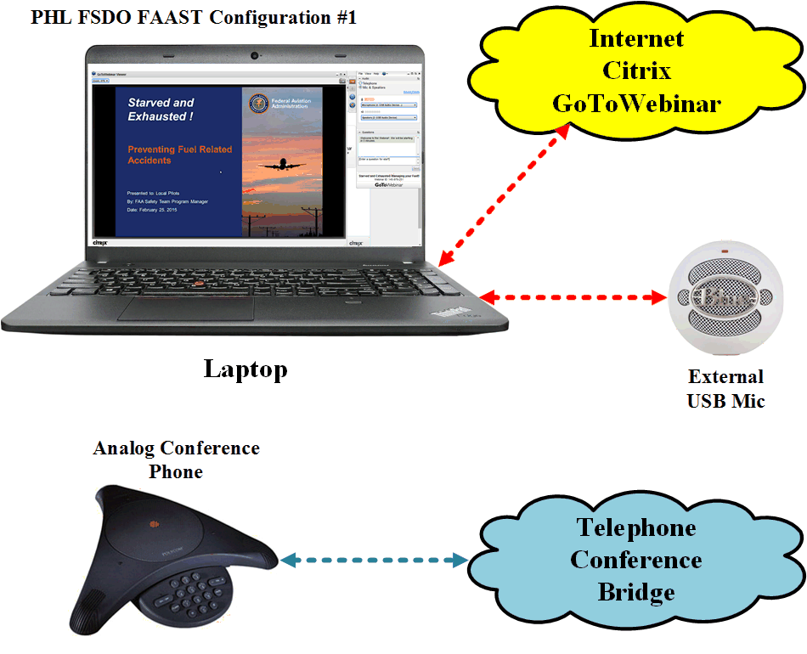

This Visio schematic illustrates another alternative for the PHL FSDO FAAST presenter’s configuration. This configuration would be useful when the FAAST members delivering the presentation was at one locations and the supporting FAAST members were at the other locations. The author would use the aviation headset connected to the iPhone via Bluetooth.

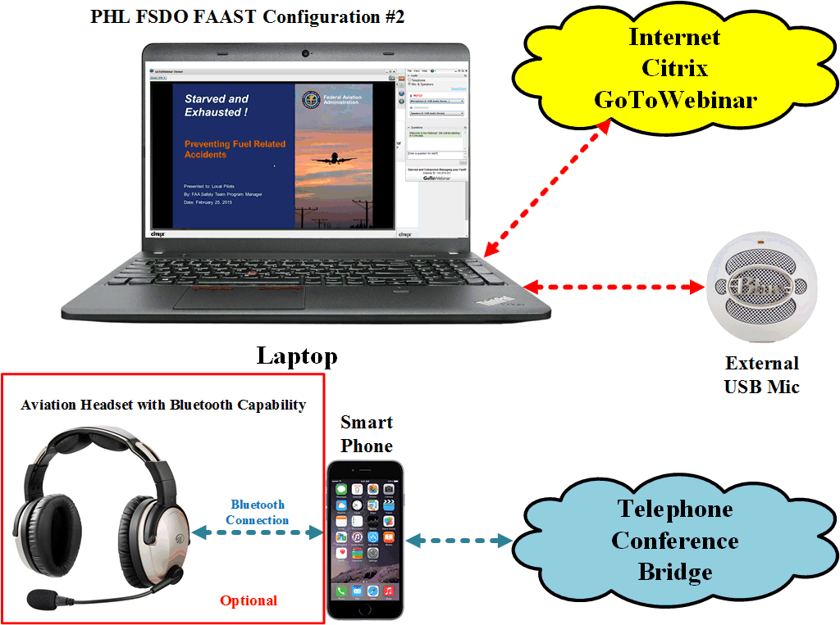

The PHL FSDO FAAST webinars team should consider the following for next steps:

* Get organizer access to Citrix GoToWebinar using the FAA’s licensing and credentials
* Practice a “mock” presentation as a “proof of concept”
* Conduct a dry run of each live webinar the night before or morning before the live webinar.
* Acquire the equipment recommended in the Appendices
  + Appendix 1 – USB Microphone and Analog Conference Phone
  + Appendix 2 – USB Headsets with Microphones

**Appendix 1 – USB Microphone and Analog Conference Phone**

|  |  |  |
| --- | --- | --- |
| **USB Microphone and Analog Conference Phone** | | |
| **Device** | USB Microphone | Analog Conference Speakerphone |
| **Make** | Blue Microphones | Polycom |
| **Model** | Snowball USB | [Polycom SoundStation 100](http://poly.factoryoutletstore.com/details/7251/polycom-2200-00106-001.html?category_id=11521) |
| **Price** | $99.99 | $112.99 |
| **Vendor** | Best Buy | Polycom |
| **Picture** |  |  |
| **Link** | <http://www.bestbuy.com/site/blue-microphones-snowball-usb-condenser-microphone-white/9917949.p?id=1218194638421&skuId=9917949> | <http://poly.factoryoutletstore.com/cat/11521-7251/Polycom-Soundstation.html?cid=7868&chid=4272&gclid=CJWou8ysgsQCFUk2gQodVQYAMw> |

**Appendix 2 – USB Headsets with Microphones**

|  |  |  |  |
| --- | --- | --- | --- |
| **USB Headset with Microphone** | | | |
| **Brand** | **LogiTech** | **LogiTech** | **Cyber Acoustics** |
| **Model** | **H390** | **H540** | **AC850** |
| **Price** | **$24.99** | **$29.99** | **$18.99** |
| **Picture** |  |  |  |
| **Vendor** | **Best Buy** | **Best Buy** | **Amazon** |
| **Link** | <http://www.bestbuy.com/site/logitech-h390-usb-headset-with-noise-canceling-microphone-black/9618932.p?id=1218372418314&skuId=9618932> | <http://www.bestbuy.com/site/logitech-h540-on-ear-usb-headset-black/6640621.p?id=1218770737042&skuId=6640621> | <http://www.amazon.com/Cyber-Acoustics-AC-850-Internet-Communication/dp/B00083Y0T6/ref=sr_1_fkmr0_3?s=electronics&ie=UTF8&qid=1425045206&sr=1-3-fkmr0&keywords=cyber+acoustics+ac201+headset+with+microphone+usb> |