**Purpose**

* To provide area pilots with an overview of how the PHL Class B airspace has changed as well as how they might obtain more information on this change.

**FAA Safety Seminars on the changes to the PHL Class B airspace**

* Attend one of the FAA Safety Seminars on this topic. The PHL FSDO is really trying to saturate their coverage area with seminars on this change.
  + 7/17/2013 at PHL FSDO – past event

<https://www.faasafety.gov/SPANS/event_details.aspx?eid=50141&caller=/SPANS/events/EventList.aspx>

* + 7/24/2013 at PNE Jet Center – past event

<https://www.faasafety.gov/SPANS/event_details.aspx?eid=50590&caller=/SPANS/events/EventList.aspx>

* + 7/30/2013 at Wings Field

https://www.faasafety.gov/SPANS/event_details.aspx?eid=50646&caller=/SPANS/events/EventList.aspx

* + 8/5/2013 at New Castle County Airport

https://www.faasafety.gov/SPANS/event_details.aspx?eid=50687&caller=/SPANS/events/EventList.aspx

* + 8/8/2013 at Flying W Airport

<https://www.faasafety.gov/SPANS/event_details.aspx?eid=50648&caller=/SPANS/events/EventList.aspx>

* + 8/20/2013 at Toms River Library

<https://www.faasafety.gov/SPANS/event_details.aspx?eid=50804&caller=/SPANS/events/EventList.aspx>

**Charts impacted by this change**

* Pilots can download charts from the FAA website. The links below provide the ability to do this
  + VFR Charts, both Sectional Charts and Terminal Area Charts or TAC charts are available at the link below.
    - <http://www.faa.gov/air_traffic/flight_info/aeronav/digital_products/vfr/>
    - For Sectional Charts, click on the Sectional tab.
    - For Terminal Area Charts, click on the Terminal Area tab
* The charts listed below are effective 7/25/2013 and reflect the changes to the PHL Class B airspace. They are a “must have.” I received mine in the mail from my Sportys subscription.
  + **Philadelphia Terminal Area Chart** – can be downloaded at the link below

<http://aeronav.faa.gov/content/aeronav/tac_files/Philadelphia_TAC_80.zip> - a 16 MB Zip file

* + **New York Sectional Chart** – can be downloaded at the link below

<http://aeronav.faa.gov/content/aeronav/sectional_files/New_York_89.zip> - a 55 MB Zip file

* + **Washington Sectional Chart** – can be downloaded at the link below

<http://aeronav.faa.gov/content/aeronav/sectional_files/Washington_96.zip> - a 47 MB Zip file

**Old PHL Class B Airspace**

* This figure illustrates the “old” PHL Class B airspace. Note how the side of the “wedding cake” is cutoff in New Jersey.

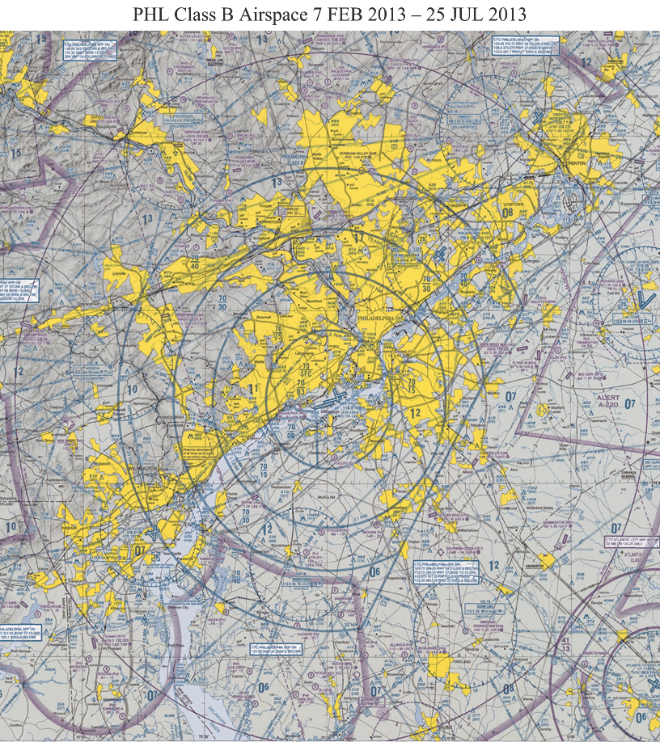

**New PHL Class B Airspace**

* This figure illustrates the “new” PHL Class B airspace. Note how the side of the “wedding cake” is now rounded out in New Jersey.

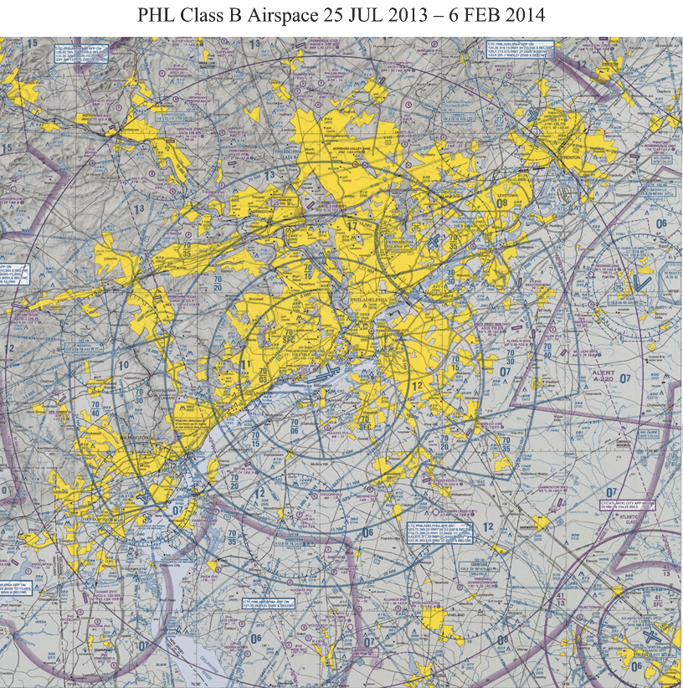

**Underlying Airports**

* This figure illustrates changes to the Class B floor over area airports.
  + The floors have changed for ILG, 19N, N14, N73, VAY, PNE, OQN, and LOM

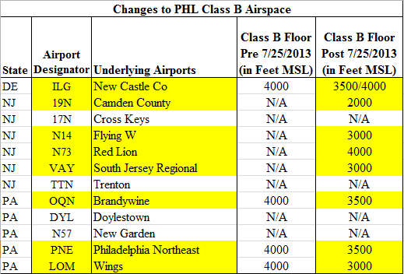

**Class B Operating Procedures**

* The Class B operating procedures have not changed.
  + VFR flight requirements
    - Pilot requirements: at least a private pilot certificate or as noted in FAR 91.131(b)
    - Need a clearance into the Class B (FAR 91.131)
    - Need an operable two-way radio capable of communicating with ATC on the appropriate frequencies for that Class B airspace and an operable Mode C transponder(FAR 91.131)
    - Weather conditions (FAR 91.155)
      * Visibility: 3 statute miles
      * Cloud Distance: clear of clouds
  + IFR flight requirements
    - Pilot requirements: at least a private pilot certificate and an instrument rating
    - Need an operable VOR or TACAN receiver or a suitable RNAV system (FAR 91.131)
    - Need an operable two-way radio capable of communicating with ATC on the appropriate frequencies for that Class B airspace and an operable Mode C transponder(FAR 91.131)

**Pre-flight Planning and Training**

* Very important that pilots do the following
  + Thoroughly plan their flights through this changed Class B airspace
  + Understand and have achieved proficiency in the navigation systems on board their respective aircraft
  + Develop and maintain situational awareness as it will play an important role in successfully navigating this airspace
  + Get flight instruction as necessary

**What to Do If You Think You May Have Had a Class B Airspace Incursion**

* NASA Aviation Safety Reporting System (ASRS)
  + The ASRS collects, analyzes, and responds to voluntarily submitted aviation safety incident reports in order to lessen the likelihood of aviation accidents.
  + ASRS data are used to:
  + Identify deficiencies and discrepancies in the National Aviation System (NAS) so that these can be remedied by appropriate authorities.
  + Support policy formulation and planning for, and improvements to, the NAS.
  + Strengthen the foundation of aviation human factors safety research. This is particularly important since it is generally conceded that over two-thirds of all aviation accidents and incidents have their roots in human performance errors.
  + When a pilot submits an ASRS report, an enforcement action may not be taken for a reported event if all of the following conditions are met:
  + The pilot’s action or lack of action was inadvertent.
  + The pilot’s action or lack of action did not involve a criminal offense or accident.
  + The pilot shows proof that within 10 days after the occurrence, he/she completed and submitted, electronically or by mail, a report to NASA’s ASRS.
* Submitting a NASA report
  + Go to the link <http://asrs.arc.nasa.gov/report/electronic.html>
  + This will give you the screen shown below
  + Click “General” under “Submit Reporting Form (ERS)”

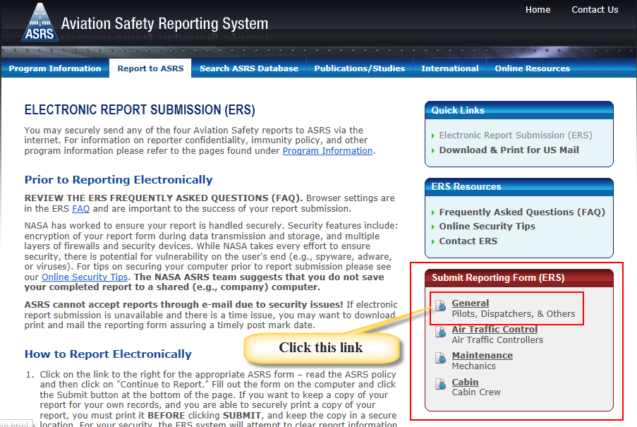

* + This will display the screen below. Click “Continue to Report.”

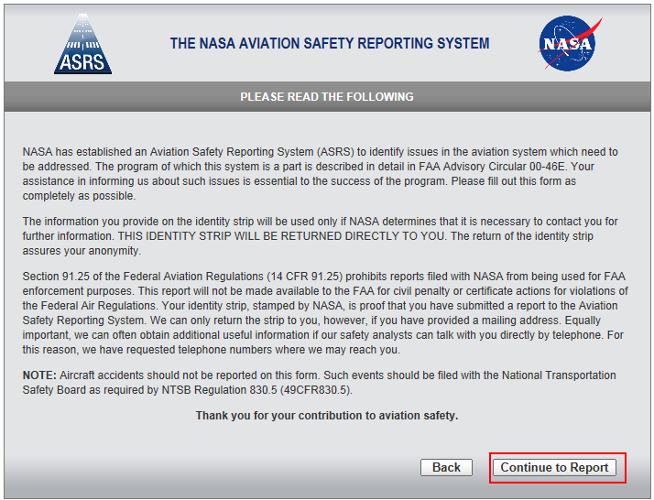

* + Enter your contact information

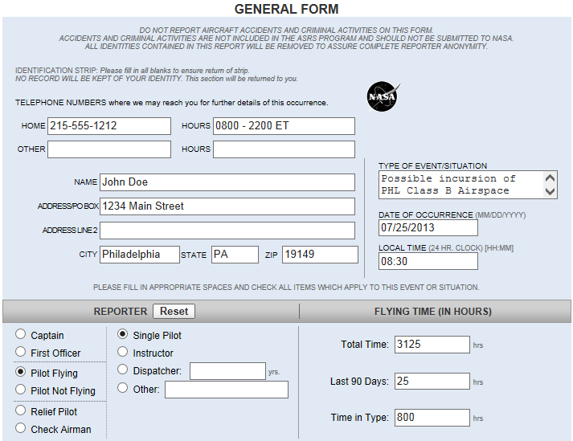

* + Enter your certificates and ratings as well as the conditions of flight

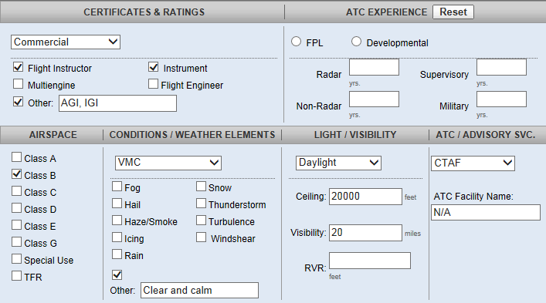

* + Enter information about your aircraft and routing

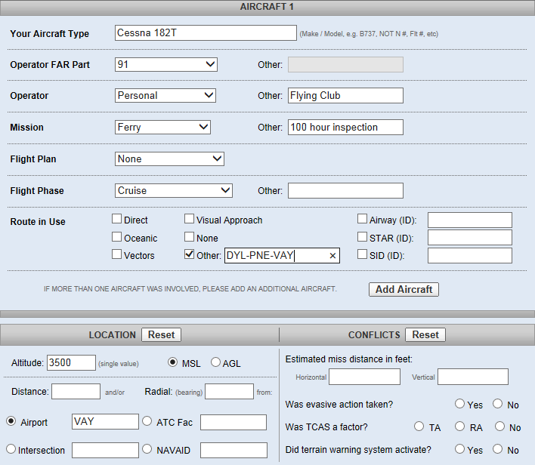

* + Describe the event/situation
  + Print a copy of the report for your records
  + Submit your report
  + You should do this as soon as possible after the event while everything is fresh in your mind

