

**Tips for Flying in the**

**Wilmington TFR**

**Updated March 18, 2021**

## DISCLAIMER: This document was written using input from stakeholders in the Philadelphia area. It is not endorsed or approved by any ATC facility, the FAA, or any government agency responsible for this, or any other, TFR. We did our best to provide accurate and timely information. However, the information contained in this document may be hopelessly out of date, or wrong. The author bears no responsibility for your actions or for any problems that may arise from the use of the information contained herein. TFRs change. Always check with Flight Service before flying.

PLEASE READ THIS **ENTIRE** DOCUMENT

Welcome!

We understand that operating within any TFR can be a challenge. We also understand that many pilots may not know who to ask, or where to obtain the critical information necessary to safely operate within a TFR - especially the **~~Bedminster~~** **Wilmington** TFR.

In an effort to reduce the number of pilot deviations and intercepts that occur during **~~Bedminster~~** **Wilmington** TFRs, we are providing you with this document which we hope will answer most, if not all of your questions.

Flying is a privilege! Before proceeding, we would like to remind you to review Intercept Procedures (provided at the end of this document), and the following regulations.

91.3 Responsibility and authority of the pilot in command

91.13 Careless or reckless

91.103 Preflight action

91.133 Restricted and prohibited areas

91.141 Flight restrictions in the proximity of the Presidential and other parties Please pass this on to all your pilot friends expecting to operate in this airspace during the TFR.

## Original Author

## Don Argintar CFI/II

Questions, comments, or corrections: [flightmatters@gmail.com](mailto:flightmatters@gmail.com)

**Airports Within 12nm Core - Flight Prohibited**

|  |  |  |
| --- | --- | --- |
| Airport | State | Name |
| |  | | --- | | ILG | | N57 | | JY39 | | |  |  | | --- | --- | | DE | NEW CASTLE AIRPORT | | PA | NEW GARDEN AIRPORT | | NJ | RAINBOW'S END AIRPORT | | |  | | --- | | NEW CASTLE AIRPORT | | NEW GARDEN AIRPORT | | RAINBOW'S END AIRPORT | |
|  |  |  |
|  |  |  |

## Airports With Cutouts - No ATC Contact Required Though Still Recommended

|  |  |  |  |  |
| --- | --- | --- | --- | --- |
| Airport | State | Name | Cutout radius | Arrival / Departure Direction |
| **KAPG** | **MD** | **Phillips AAF** |  |  |
| **KPTW** | **PA** | **Heritage Field** |  |  |
| **N10** | **PA** | **Perkiomen Valley** |  |  |
| **S37** | **PA** | **Smoketown** |  |  |
| **17N** | **NJ** | **Cross Keys** |  |  |
|  |  |  |  |  |

**Airports* Within 30nm Ring, Outside 12nm Core - ATC Contact Required**

|  |  |  |  |  |  |  |  |  |
| --- | --- | --- | --- | --- | --- | --- | --- | --- |
| Airport | State | Name | Tower | Facility | Radio | Freq | Phone | Egress / Ingress |
| |  | | --- | | 7N7 | | 93MD | | EVY | | 3PA8 | | 58M | | 6NJ9 | | 16MD | | NJ74 | | 1DE5 | | OQN | | MQS | | 24NJ | | JY08 | | 9N2 | | MD61 | | DE34 | | 7NJ2 | | 9NJ5 | | NJ25 | | PHL | | DE29 | | 04NJ | | PA70 | | NJ84 | | DE20 | | M06 | | 7NJ7 | | 29MD | | JY31 | | JY17 | | 6MD7 | | 61NJ | | MD93 | | NJ06 | | DE19 | | 6MD4 | | 23DE | | 38N | | 43PA | | 34NJ | | 0W3 | | MD1 | | O03 | | 00N | | 9PA0 | | 5PA4 | | PA61 | | APG | | 4MD6 | | 9NJ6 | | 17N | | 23NJ | | |  | | --- | | NJ | | MD | | DE | | PA | | MD | | NJ | | MD | | NJ | | DE | | PA | | PA | | NJ | | NJ | | PA | | MD | | DE | | NJ | | NJ | | NJ | | PA | | DE | | NJ | | PA | | NJ | | DE | | MD | | NJ | | MD | | NJ | | NJ | | MD | | NJ | | MD | | NJ | | DE | | MD | | DE | | DE | | PA | | NJ | | MD | | MD | | PA | | NJ | | PA | | PA | | PA | | MD | | MD | | NJ | | NJ | | NJ | | |  | | --- | | SPITFIRE AERODROME AIRPORT | | KNOLLWOOD FARM AIRPORT | | SUMMIT AIRPORT | | HARRIS AIRPORT | | CLAREMONT AIRPORT | | BRIDGEPORT-CAHILL FIELD AIRPORT | | HIGH VALLEY AIRPORT | | SALEM AIRFIELD AIRPORT | | MCKEOWN AIRPORT | | BRANDYWINE REGIONAL AIRPORT | | CHESTER COUNTY G O CARLSON AIRPORT | | TAILDRAGGER ACRES AIRPORT | | VAR-SKY AIRPORT | | PHILADELPHIA SEAPLANE BASE | | LYNCH'S LANDING AIRPORT | | TOWNSEND A AIRPORT | | STOE CREEK FARM AIRPORT | | STALLONE AIRPORT | | PEASLEES AIRSTRIP AIRPORT | | PHILADELPHIA INTERNATIONAL AIRPORT | | SCOTTY'S PLACE AIRPORT | | EMMANUEL AIRPORT | | FETTERS CONSTRUCTION AIRPORT | | HIDDEN ACRES FARM AIRPORT | | SPIRIT AIRPARK AIRPORT | | HAVRE DE GRACE SEAPLANE BASE | | COOMBS AIRPORT | | SCHLOSSER AIRPORT | | WIDE SKY AIRPARK AIRPORT | | WOODCREST FARMS AIRSTRIP AIRPORT | | D'ANGELO AIRPORT | | THOMAS BROWNE AIRPARK AIRPORT | | HEXTON FARMS AIRPORT | | B J FARMS AIRPORT | | DUFFY'S AIRPORT | | PEMBROKE FARM AIRPORT | | FULL THROTTLE FARM AIRPORT | | SMYRNA AIRPORT | | KOLB AIRPORT | | BLEWS AIRPORT | | HARFORD COUNTY AIRPORT | | MASSEY AERODROME AIRPORT | | MORGANTOWN AIRPORT | | BUCKS AIRPORT | | LANCE AIRPORT | | NESSPOR AIRPORT | | KUNDA AIRPORT | | PHILLIPS AAF AIRPORT | | MOXLEY'S AIRPORT | | HALKA NURSERIES AIRPORT | | CROSS KEYS AIRPORT | | ALLIANCE AIRPORT | | |  | | --- | |  | | _ | |  | | _ | |  | |  | |  | |  | |  | |  | |  | |  | |  | |  | |  | |  | |  | |  | |  | | ✔ | |  | |  | |  | |  | |  | |  | |  | |  | |  | |  | |  | |  | |  | |  | |  | |  | |  | |  | |  | |  | |  | |  | |  | |  | |  | |  | |  | | ✔ | |  | |  | |  | |  | | |  | | --- | | MIV | | _ | | MIV | | _ | |  | |  | |  | |  | |  | |  | |  | |  | |  | |  | |  | |  | |  | |  | |  | |  | |  | |  | |  | |  | |  | |  | |  | |  | |  | |  | |  | |  | |  | |  | |  | |  | |  | |  | |  | |  | |  | |  | |  | |  | |  | |  | |  | |  | |  | |  | |  | |  | | |  | | --- | | CTAF | | _ | |  | | _ | |  | |  | |  | |  | |  | |  | |  | |  | |  | |  | |  | |  | |  | |  | |  | |  | |  | |  | |  | |  | |  | |  | |  | |  | |  | |  | |  | |  | |  | |  | |  | |  | |  | |  | |  | |  | |  | |  | |  | |  | |  | |  | |  | |  | |  | |  | |  | |  | | |  | | --- | | 122.7 | | _ | | 122.725 | | _ | |  | |  | |  | |  | |  | |  | |  | |  | |  | |  | |  | |  | |  | |  | |  | |  | |  | |  | |  | |  | |  | |  | |  | |  | |  | |  | |  | |  | |  | |  | |  | |  | |  | |  | |  | |  | |  | |  | |  | |  | |  | |  | |  | |  | |  | |  | |  | |  | | |  | | --- | | 484-32-4851 | | 856-689-4892 | | 302-834-5400 | | 610-999-9080 | | 410-398-0234 | | 609-299-8520 | | 443-309-4816 | | 856-759-4256 | | 302-545-2340 | | 610-692-6100 | | 610-383-6057 | | 856-297-3041 | | 856-769-2104 | | 610-521-3530 | | 215-932-3851 | | 302-325-9337 | | 856-935-0613 | | 609-478-2510 | | 856-224-0218 | | 215-937-6914 | | 302-653-8722 | | 856-358-7374 | | 215-458-5201 | | 856-451-5966 | | 302-378-1396 | | 410-258-9648 | | 856-358-3764 | | 410-755-6500 | | 609-670-1434 | | 856-451-8224 | | 410-755-6930 | | None listed | | 410-275-2626 | | 609-451-7005 | | 302-653-1111 | | 410-378-2032 | | 302-545-3997 | | 302-653-8314 | | 610-792-0736 | | 856-455-0926 | | 410-836-2828 | | 410-928-5270 | | 610-286-9055 | | 856-649-3752 | | None listed | | 484) 336-7222 | | 267) 474-6501 | | 410-278-4902 | | 443-752-5196 | | 908-462-8450 | | 856-629-3033 | | 856-794-2391 | |  | | |  | | --- | |  | | _ | |  | | _ | |  | |  | |  | |  | |  | |  | |  | |  | |  | |  | |  | |  | |  | |  | |  | |  | |  | |  | |  | |  | |  | |  | |  | |  | |  | |  | |  | |  | |  | |  | |  | |  | |  | |  | |  | |  | |  | |  | |  | |  | |  | |  | |  | |  | |  | |  | |  | |  | |

**(*Heliports, seaports, private, military, ultralight, and unverified fields are not included)**

# About ATC

While it may seem counter-intuitive, **PHL and NY Tracon are** actually busier during a TFR. ATC tracks and provides advisories (flight following) to **all** VFR aircraft. In a non-TFR environment, advisories are provided on a workload permitting basis. In a TFR environment, everyone gets advisories.

Depending on the time of day, this could mean that you may need to wait on the ground for some time prior to departure. ATC is not ignoring you, they just need to “open a window” for you to depart. Please exercise patience and be considerate to ATC. ATC is doing a difficult job, and they do it very well.

# General Remarks

Whether you are operating IFR or VFR, flying into or out of the **~~Bedminster~~ Wilmington** TFR is simple. File a flight plan, get a squawk code, get an ingress or egress clearance, remain clear of the **~~10~~ 12** nm inner core, and stay in communication with ATC until they instruct you otherwise. In other words, **squawk and talk!**

The rest of this document spells out the details!

* **Always** contact Flight Service before any flight.
* You may be delayed when departing from a **YELLOW** airport until ATC can fit you into the traffic flow. Consider possible delays in your fuel and flight planning.
* Communications with **PHL and NY Tracon** may be difficult at times due to rapid-fire exchanges. If you depart and are unable to “break-in”, continue on your planned egress route. Do **not** enter **PHL Class Bravo** without an explicit clearance. If you are uneasy about communicating with ATC, you may be better off staying on the ground.
* Make sure your cockpit instrumentation and displays are properly set and configured to ensure you fly accurate headings and altitudes. Squawk altitude with your transponder.
* You **must** file a VFR or IFR flight plan prior to egressing or ingressing the TFR. Your VFR flight plan

**does not ???** need to be activated. Your IFR flight plan **does** need to be activated.

* Do **not** depart VFR with the intention of picking up an IFR clearance in the air from **PHL and NY Tracon**.
* Though it may be more convenient for you to transit the TFR in your intended direction of flight, we recommend that you egress and ingress the TFR using the shortest possible route. We recommend using airports as fixes to fly to/from when egressing / ingressing the TFR, instead of using VORs, intersections and other waypoints used in IFR flights.
* When flying VFR, keep your head on a swivel and your **eyes outside**.
* Do not fly any closer than 3 nm to the TFR boundary unless you have established contact with ATC **and** received a squawk code. The only exceptions are ingress and egress from the six **GREEN** airports with cutouts.
* **IMPORTANT**: Relying on a portable GPS for precise VFR navigation is at the sole risk of the pilot in command. If you decide to utilize a portable GPS to navigate through the TFR under VFR, we recommend you back up the device with current VFR charts and any other radio navigation sources which are appropriate and available, and that you display your cross-track error (XTK), or use the HSI page for guidance. Use of the map page, alone, may not provide sufficiently accurate lateral guidance.
* Navigating inside the TFR using only pilotage is **not** recommended.
* Transiting the Hudson River SFRA while the TFR is active is **not** recommended. N/A ???
* If you make a mistake by transiting airspace through which you are not authorized, do **not** attempt to fly low thinking you will avoid radar detection. You won’t. Correct your mistake and communicate with ATC **immediately** to straighten out any misunderstanding.
* If possible, monitor guard frequency, 121.5, while operating within the TFR.
* **Your aircraft must be equipped with ADS-B Out** to operate within the **PHL ??? and** **NY Class Bravo Mode-C veil and while operating above 10,000 feet MSL** (14 CFR 91.225, AIM 3-2-3). While the TFR is active, requesting an ATC deviation from equipage requirements is **not** recommended.

# Explanation of the Tables on Page 2

The **RED** table lists the airports that fall **within the 12 nm inner core**. With regrets, flight is prohibited. If you wish to continue flying during the TFR, make arrangements to move your airplane to an airport outside of the inner core for the duration of the TFR.

The **YELLOW** table lists the airports that fall **within the 30 nm outer ring, but outside the 10 nm core**. You may fly during the TFR, but you **must** file a VFR or IFR flight plan **and** follow a few simple procedures. There are **~~four~~ two** airports within the TFR with an operating control tower (**~~Newark, Caldwell, Morristown, Trenton-Mercer~~ New Castle County (KILG) and Philadelphia International (KPHL)**). Please be sure to read about any special procedures they may implement during the TFR (see below). For each airport, we list the air traffic control facility, if the airport has a GCO or Clearance Delivery frequency (and, what that frequency is), a telephone number to pick up your clearance, and a **suggested** route of flight to egress / ingress the TFR. Use the GCO or CLNC DEL frequency if provided. Use the telephone number if there is no GCO or CLNC DEL frequency, or if you get no response using your communications radio. The suggested routes are intended to take you to the nearest airport immediately outside of the TFR.

The **GREEN** table lists the airports that **have cutouts**. If you are flying to or from these airports and are **not** entering the TFR, there is no need to file a flight plan (unless you want to) or to call ATC for a squawk code. We listed the cutout radii around the airport to impress upon you **not** to extend your downwind legs. Upon departure or arrival, keep your ground track as close as possible to the airport. The last column **recommends** a direction of flight to and from the airport so as to keep you away from the TFR. For example, if departing **~~Greenwood~~ ~~Lake~~ Smoketown Airport**, depart on a **~~northeast~~ northwest** heading. Conversely, if arriving at **~~Greenwood~~ ~~Lake~~ Smoketown Airport** **airport**, approach the airport on a southwest heading.

# Pre-flight Briefings

There are two basic kinds of TFRs, graphical and textual. Users of ForeFlight, Garmin Pilot, or any other iPad application, as well as XM equipped avionics (Garmin G1000, 430, 530, etc.) should **not rely** on their displays to determine where and when a TFR is active. These products display graphical TFRs only. It is true that presidential TFRs are generally graphical, but textual changes can happen.

It may surprise you to learn that the **tfr.faa.gov** website only displays graphical TFRs. **Call Flight Service** (1-800-WXBRIEF) right before you get into your airplane and confirm the status and location of the TFR. This is the **only way** to be sure you have complete and accurate information.

**WARNING**: It is not uncommon for TFRs to “spring up” at ~~Newark Airport (KEWR) and Morristown Airport (KMMU)~~ **and Philadelphia Northeast Airport (KPNE) and Philadelphia International Airport (KPHL)** supporting VIP movements to and from **~~Bedminster~~ Wilmington.** If this happens, with respect to any information contained in this document, **all bets are off**. **Call Flight Service for guidance**.

# Departing VFR

When departing VFR from a **YELLOW** airport, we recommend the following procedure:

* File your VFR flight plan either with Flight Service or using an electronic app. For your destination, we suggest entering an egress airport as shown the rightmost column of the **YELLOW** chart.
  + **For ~~example~~, if you are departing from Blairstown, your departure is “1N7”, your route is “D” (for direct to), and your destination is “N53”.**
  + For example, if you are departing from **Chester County**, your departure is “**KMQS**”, your route is “D” (for direct to), and your destination is **Lancaster or “KLNS**”.
* Just prior to getting in your airplane to depart, **call Flight Service,** ask for an **abbreviated brief**

## and confirm the status and location of the TFR.

* If your departure airport has a GCO or Clearance Delivery frequency listed, call ATC on that frequency to obtain your squawk code. We recommend you use the following phraseology:

**~~“[New York] clearance delivery, [123AB] is a [Cessna 172] at [Lincoln Park] Airport with a VFR, TFR flight plan on file, request squawk code, [northbound] departure direct [Greenwood Lake Airport, 4N1].”~~**

**“[Philadelphia] clearance delivery, [123AB] is a [Cessna 172] at [Doylestown] Airport with a VFR, TFR flight plan on file, request squawk code, [southbound] departure direct [Brandywine Regional Airport, KOQN].”**

* If ATC can arrange for separation, they will provide you with a squawk code and clear you for departure. If not, they will ask you to call them back in a few minutes. **Do not depart without a squawk code and a clearance.** ATC will also provide you with a frequency to contact them once you’re airborne. Due to terrain and line-of-sight issues, you may not be able to hear or talk to ATC until you are 1,000’ AGL, or higher.
* Fly directly out of the TFR to your point of egress.
* If your departure airport is situated under the **~~New York~~** **Philadelphia** Bravo, **do not enter the Bravo without an explicit clearance.**

# Arriving VFR

When arriving VFR to a **YELLOW** airport, we recommend the following procedure:

* File your VFR ingress flight plan either with Flight Service or using an electronic app. **Also, request a four digit discrete squawk code for your transponder.** For your departure airport, we suggest entering an ingress airport as shown the rightmost column of the **YELLOW** chart. For example, if you are flying into Blairstown, your departure is “N53”, your route is “D” (for direct to), and your destination is “1N7”.
* We recommend that you file this flight plan on the ground before you depart, but you can also file the flight plan in the air with Flight Service.
* When 10 nm from the ingress fix, call ATC (this could be New York, Allentown or Philadelphia, depending on your direction of flight). We recommend you use the following phraseology:

**~~“[Allentown] Approach, [123AB] is a [Cessna 172], 10 miles [west of Pennridge], [2700’] with a VFR, TFR flight plan on file, direct [Sky Manor, N40], request squawk code.”~~**

**“[Philadelphia] Approach, [123AB] is a [Cessna 172], 10 miles [north of Philadelphia Northeast], [2700’] with a VFR, TFR flight plan on file, direct [Brandywine, KOQN], request squawk code.”**

* You are **not cleared** into the TFR until ATC acknowledges your tail number, provides you with a squawk code, identifies you on radar, and clears you into the TFR. Remember, entering the **~~New York~~** **Philadelphia** Class Bravo airspace requires its own, separate, clearance.
* Fly directly from your point of ingress to your destination.
* Flight training (pattern work, touch and gos, etc.) is prohibited inside the TFR.
* ATC will advise you when to switch to CTAF. **Do not switch to CTAF until ATC clears you to do so.**
* Keep your squawk code until you shut your engine down.

# Departing / Arriving IFR

Use the same procedures as always to arrive / depart IFR. Please note that you may be faced with unusually long departure delays. **~~If you are departing from Morristown, Caldwell or Trenton-Mercer, please review the routing changes, below~~**.

It has come to our attention that on several occasions, IFR aircraft ingressing the TFR in VFR conditions may be “offered” to cancel early, squawk 1200 and change to advisory frequencies. The idea is simple, you have a flight plan on file, ATC knows what you are doing and they are relieving their work load to help other pilots. **We recommend that you keep your IFR until you are on the ground. Then, if flying to a non-towered airport, promptly call ATC to cancel.** If, however, you wish to cancel early, **keep your squawk code until you shutdown.**

**Chester County Airport (KMQS) - Additional Procedures**

# IFR

* All runways are available for arrival
* All runways are available for departure
* The only instrument approach procedure that **can be authorized** is **ILS or LOC RWY 23**, with a missed approach hold at **CAT**.
* Instrument approach procedures that **cannot be authorized** are: RNAV (GPS) RWY 5

RNAV (GPS) Y RWY 23 RNAV (GPS) Z RWY 23

* Visual approaches **can** be authorized
* Contact approaches **cannot** be authorized
* All IFR departures will be assigned the **Morristown Seven** procedure
* BIGGY, PARKE, LANNA, ELIOT, NEWEL, ZIMMZ transitions **cannot be authorized** and will be re- routed over WHITE, COATE, NEION or GAYEL.
* TEC routes filed via SJB (V3), FJC (V6 and V162), ETX (V30), BUSKY, SAX direct SBJ at 8,000’, BWZ at 4,000’ **cannot be authorized**. You should change your route to KMMU* … SAX… COATE.V188.LVZ …Destination, your altitude must be 8,000’, 9,000’ or 10,000’. This restriction applies to both RNAV and non-RNAV.

This is the hottest time of summer. Make sure you properly calculate your climb performance prior to departure. If you are assigned runway 23 and your climb rate is insufficient, you will be too far south prior to reaching 2,000’ (with a turn to heading 160) and you may violate the 10 nm inner core. If you cannot reach 2,000’ within 2 nm of the departure end of the runway, we recommend that you advise the tower you will be turning a little early and at a lower altitude to heading 160 to avoid the 10 nm core. We do not recommend this procedure when the visibility is less than 7 nm as you will not be able to adequately provide your own obstacle clearance. **As a general rule, be prepared to make your turn to a heading of 160 within 2 nm from the departure end of the runway**.

# VFR

* When you call ground for a taxi clearance, advise you have your VFR flight plan filed. We recommend the following phraseology:

“Morristown Ground, [Cessna 123AB], [west tie-down] with [Lima], VFR, TFR flight plan on file to [Greenwood Lake] airport, request taxi”

* Westbound and southbound departures will take much longer to coordinate with ATC. We recommend that you file your VFR flight plan to and from Greenwood Lake airport (4N1).
* If you depart from runway 23 or 31 and are assigned a right turn out to the north, do **not** delay this turn.
* The 10 nm inner core is just over 3 nm southwest of the departure end of runway 23. **If you fly into the inner core, you’ll be in quite a bit of trouble.**
* Morristown tower will issue you a transponder code prior to release. Make sure you are squawking altitude.
* After you depart, Morristown tower will hand you off to New York TRACON. Please note that special VFR requests (more than likely) will not be authorized.

**Summit Airport (KEVY) - Additional Procedures**

# IFR

* All runways are available for arrival
* All runways are available for departure
* All instrument approaches **can be** authorized
* Visual approaches **can be** authorized
* Contact approaches **cannot be** authorized
* BIGGY, PARKE, LANNA, ELIOT, NEWEL, ZIMMZ transitions **cannot be** authorized and will be re- routed over WHITE, COATE, NEION or GAYEL
* TEC routes filed via SJB (V3), FJC (V6 and V162), ETX (V30), BUSKY, SAX direct SBJ at 8,000’, BWZ at 4,000’ **cannot be authorized**. You should change your route to KCDW SAX… COATE.V188.LVZ

…Destination, your altitude must be 8,000’, 9,000’ or 10,000’. This restriction applies to both RNAV and non-RNAV.

# VFR

* When you call ground for a taxi clearance, advise you have your VFR flight plan filed. We recommend the following phraseology:

“Caldwell Ground, [Cessna 123AB], [bravo t-hangars] with [Papa], VFR, TFR flight plan on file to [Greenwood Lake] airport, request taxi”

* Westbound and southbound departures will take much longer to coordinate with ATC. We recommend that you file your VFR flight plan to and from Greenwood Lake airport (4N1).
* Caldwell tower will issue you a transponder code prior to release. Make sure you are squawking altitude.
* After you depart, Caldwell tower will hand you off to New York TRACON. Please note that special VFR requests (more than likely) will not be authorized.

**Trenton-Mercer Airport (KTTN) - Additional Procedures**

# IFR

* No changes from normal IFR operations.
* Flight over METRO intersection is suspended.

# VFR

When egressing the TFR, you can get your squawk code from clearance delivery on the ground, using ground control frequency. When ingressing the TFR, you can get your squawk code from Philadelphia Approach on 123.8.

# The ~~Bedminster~~ Wilmington TFR

At the bottom of this page is a standard FAA graphic depicting basic TFR operations. These ideas are reflected in our notes specific to the Bedminster TFR. **Always follow FAA guidance, regulations and ATC clearances to the letter. Remember, when operating inside any TFR, the general idea is “squawk and talk”.**

On the next page are two graphics depicting the Morristown TFR (top) and the Bedminster TFR (bottom). The Morristown TFR is used when VIPs are coming into and leaving this area. Please note there are no cutouts, the center of the TFR is shifted right, and the affected airports are different.

Caldwell (KCDW), Morristown (KMMU) and Lincoln Park (N07) are within the 10 nm inner core, so flight is prohibited. The duration is expected to be one hour, but this can change. If Newark (EWR) is utilized for VIP ingress or egress, **there may be a third TFR**. **Contact Flight Service for the latest information prior to any flight.**

Next, is the text for the Bedminster TFR and NOTAMS. (See **tfr.faa.gov** for the Morristown TFR text).

Lastly, we’re including a kneeboard tip sheet from NORAD that you may wish to print out and take with you on your next flight.

Happy flying!!!

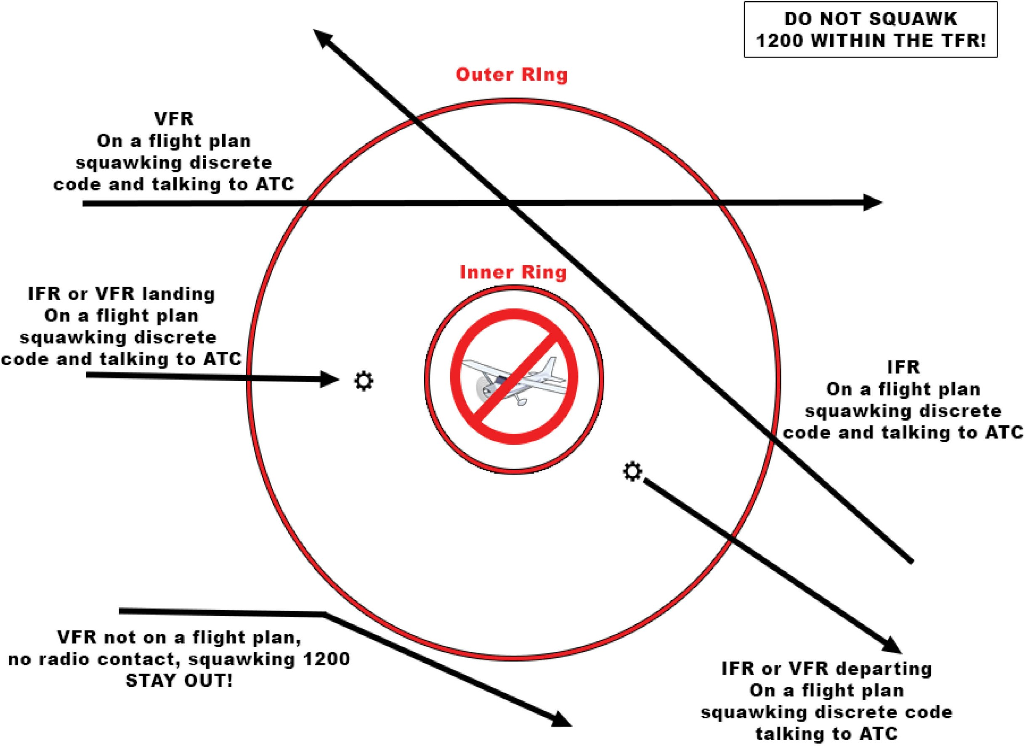

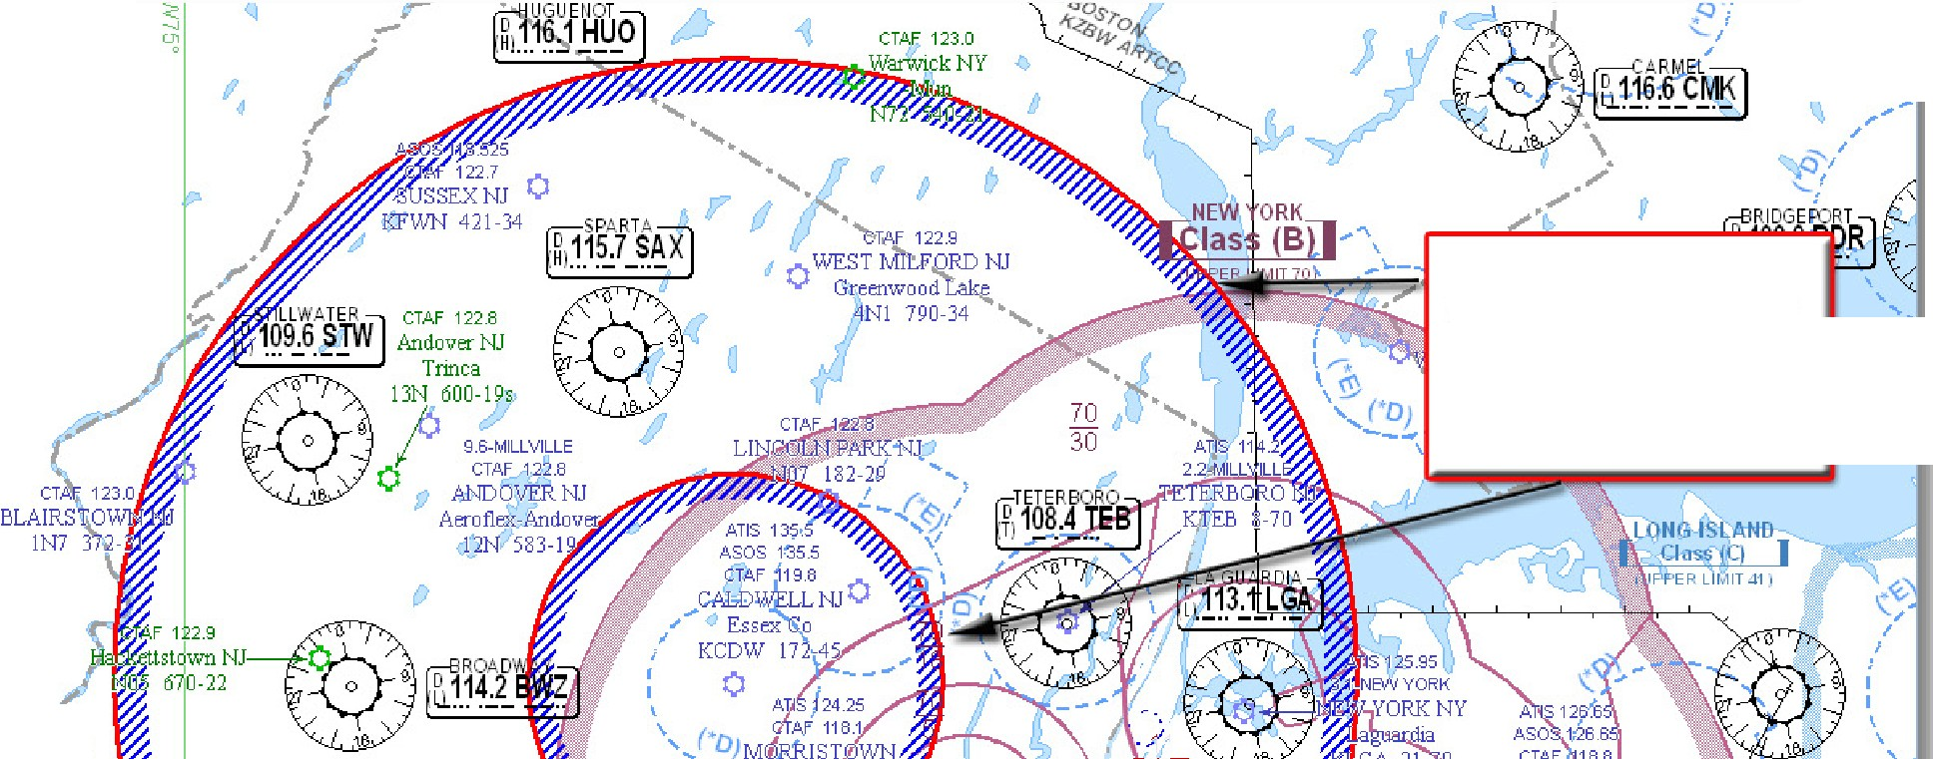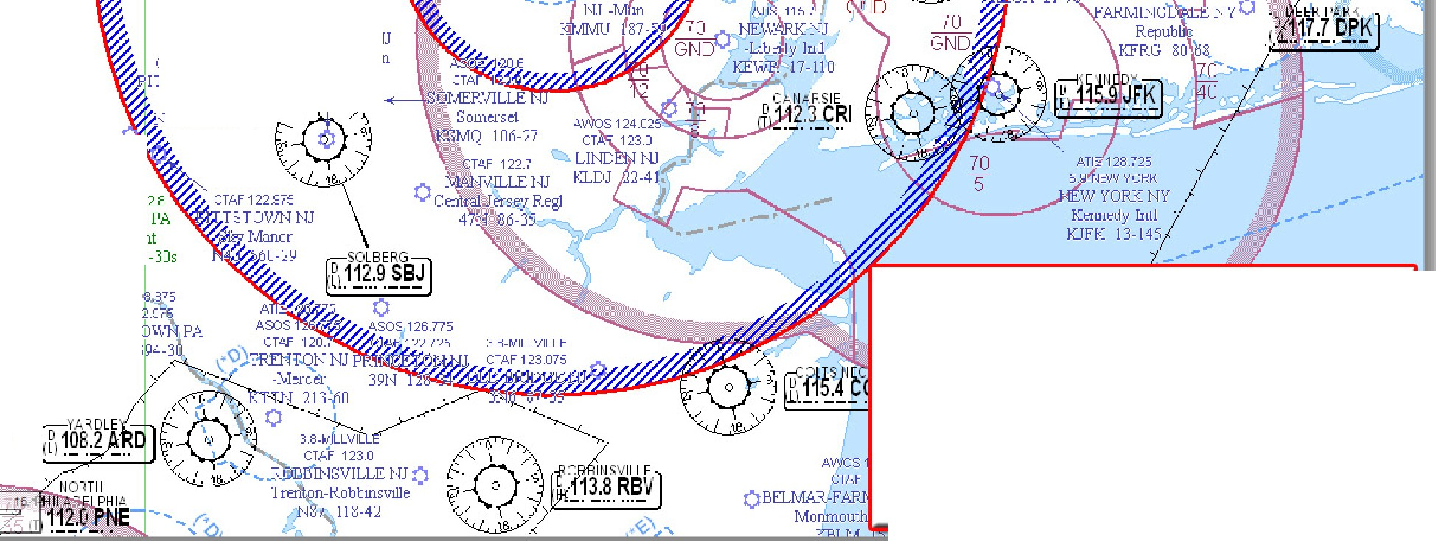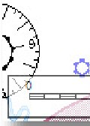

...._.,. CTM 12 /. 9

STEFLING **pf** .,.•

SpnngHill _.

70N 1729: 24

" ASOS 12027 ,/ @ TAF 122.9 \_.,.._

\

,. CTAF 1227 0 Canadens1s PA

MT f oc oNO PA Flying Donfu-

Pocono Mount.funs Mun 8N4 1430-24s

• = o 1915-50

.,.

9.6-MILLVILLE CTAF 123.0

EAST STROUDSBURG **PAO**

Stro!Jdsburg-Pocono N5J 480-30

**Area A- 30 NMR 404810N0742451W**

**1730-1845 EDT**

**2130-2245 UTC**

**Area 8 - 10 NMR**

[ Class IQ **J**

(UPPE R Ll r,1IT-l-11

ALLENTOWN

*,1Jf;* D LLEI ITOW II

@\L1. .L1

J _

A

N

4t19 7

t, TIS1 26.975

0 TOWN PA

"1

i'.'.5 1$,1LL ll'-.MSPORT_

2.9-MILLVL LE CTAF 122.8

READINGTON NJ

CT 122.975 Solberg-Hunterdon

IHS..TOWNNJ N51 189-55

A \2;:t;s 9BE 394-75

, L. ¼lley Intl

0 A-QLuUeNrnTCOitWy MNPuAn KXLL 399-39

**' •JJ**

Alexsmlna ::,'\,._

85 **480 -JJ --..J,** --'

c

**0**

j

QU

AV'KJS 119.475

l **O** i/¼ns

TAF 1 2 8

**0**

KUKT s 2€ 7i 2

*( s*126 325

1 19 d

CTAF 123.0

0 PERKASIE PA CTAF12

Peonndge DOYLEST

KCKZ 568-42

A 111!/o/25 0

PHILADELPHIA

PAWrngs

KLOM 302-37

CTAf 122

COLLEGEVIL EPA

5,.:;,. "'" • -'1.a

NAUTICAL t;1° I L E-

KDYL J

**ZNY 0/5793 ZBW 0/5792**

**Morristown, NJ**

**June 05, 2020 SFC** - **17,999 MSL**

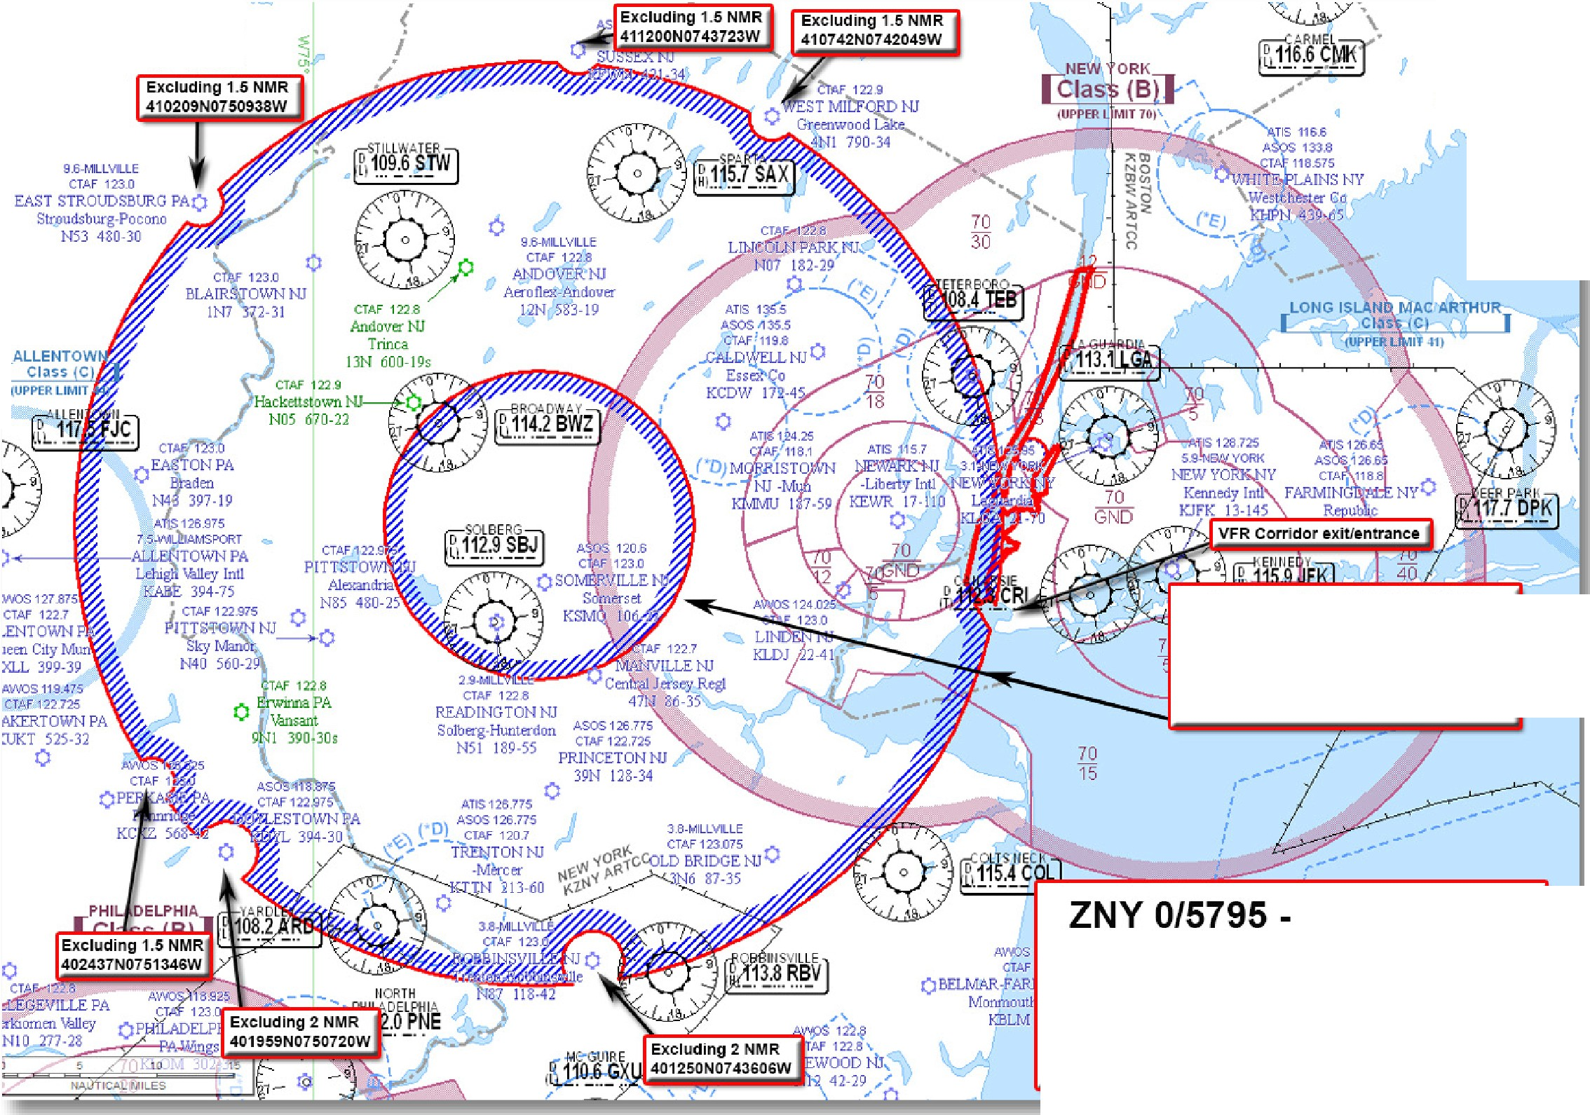

ASOS 120275

CT,.A. F 1?2.7

T POCONO PA

no Mowltains Mun

MPO 1915-50

CTAF 122.9

*OC F :'*

8 N 4 1430-24,

, ATIS f1l 1S/ ' A.SOS 119. 15

8.8 -ffilOGEFtiRT

CTAf 1 2q9

BRIDGEPOR!--GO

Slkorsky eml \

KBDR 9-47

D,11 R°I-O8O

(UPPER LIMI T

**Area A/8** - **30/10 NMR 404116N0744043W**

**6/05 1800** - **6/07 1800 EDT**

**6/05 2200** - **6/07 2200 UTC**

**ZDC 0/5794**

**Bedminster, NJ June 05-07, 2020**

**SFC -17,999 MSL**

FDC **0/8067 ZNY** NJ..AIRSPACE BEDMINSTER, NEW JERSEY..TEMPORARY FLIGHT RESTRICTIONS.

JUNE 13-14, 2020 LOCAL. PURSUANT TO 49 USC 40103(B)(3), THE FEDERAL AVIATION ADMINISTRATION (FAA) CLASSIFIES THE AIRSPACE DEFINED IN THIS NOTAM AS 'NATIONAL DEFENSE AIRSPACE'. PILOTS WHO DO NOT ADHERE TO THE FOLLOWING PROCEDURES MAY BE INTERCEPTED, DETAINED AND INTERVIEWED BY LAW ENFORCEMENT/SECURITY PERSONNEL. ANY OF THE FOLLOWING ADDITIONAL ACTIONS MAY ALSO BE TAKEN AGAINST A PILOT WHO DOES NOT COMPLY WITH THE REQUIREMENTS OR ANY SPECIAL INSTRUCTIONS OR PROCEDURES ANNOUNCED IN THIS NOTAM:

1. THE FAA MAY TAKE ADMINISTRATIVE ACTION, INCLUDING IMPOSING CIVIL PENALTIES AND THE SUSPENSION OR REVOCATION OF AIRMEN CERTIFICATES; OR
2. THE UNITED STATES GOVERNMENT MAY PURSUE CRIMINAL CHARGES, INCLUDING CHARGES UNDER TITLE 49 OF THE UNITED STATES CODE, SECTION 46307; OR
3. THE UNITED STATES GOVERNMENT MAY USE DEADLY FORCE AGAINST THE AIRBORNE AIRCRAFT, IF IT IS DETERMINED THAT THE AIRCRAFT POSES AN IMMINENT SECURITY THREAT.

PURSUANT TO TITLE 14, SECTION 91.141 OF THE CODE OF FEDERAL REGULATIONS, AIRCRAFT FLIGHT OPERATIONS ARE PROHIBITED

WITHIN AN AREA DEFINED AS 30NM RADIUS OF 404116N0744043W (SBJ035006.9) SFC-17999FT MSL;

EXCLUDING AN AREA DEFINED AS 1.5NM RADIUS OF 410209N0750938W (STW291013.5) SFC-17999FT MSL; EXCLUDING AN AREA DEFINED AS 1.5NM RADIUS OF 410742N0742049W (SAX078009.4) SFC-17999FT MSL; EXCLUDING AN AREA DEFINED AS 2NM RADIUS OF 401250N0743606W (RBV288005.0) SFC-17999FT MSL; EXCLUDING AN AREA DEFINED AS 2NM RADIUS OF 401959N0750720W (ARD306011.0) SFC-17999FT MSL; EXCLUDING AN AREA DEFINED AS 1.5NM RADIUS OF 411200N0743723W (SAX345008.8) SFC-17999FT MSL; EXCLUDING AN AREA DEFINED AS 1.5NM RADIUS OF 402437N0751346W (ARD313017.5) SFC-17999FT MSL; EXCLUDING AN AREA DEFINED AS 403608N0740334W (CRI276007.6) TO 403634N0740205W (CRI279006.4) TO 403608N0740149W (CRI275006.2) TO 403424N0740216W (CRI261007) TO THE POINT OF ORIGIN SFC-1499FT MSL EFFECTIVE 2006131630 UTC (1230 LOCAL 06/13/20) UNTIL 2006142200 UTC (1800 LOCAL 06/14/20).

WITHIN AN AREA DEFINED AS 10NM RADIUS OF 404116N0744043W (SBJ035006.9) SFC-17999FT MSL EFFECTIVE 2006131630 UTC (1230 LOCAL 06/13/20) UNTIL 2006142200 UTC (1800 LOCAL 06/14/20).

EXCEPT AS SPECIFIED BELOW AND/OR UNLESS AUTHORIZED BY ATC IN CONSULTATION WITH THE AIR TRAFFIC SECURITY COORDINATOR VIA THE DOMESTIC EVENTS NETWORK (DEN):

1. **ALL AIRCRAFT OPERATIONS WITHIN THE 10 NMR AREA(S) LISTED ABOVE, KNOWN AS THE INNER CORE(S), ARE PROHIBITED** EXCEPT FOR: APPROVED LAW ENFORCEMENT, MILITARY AIRCRAFT DIRECTLY SUPPORTING THE UNITED STATES SECRET SERVICE (USSS) AND THE OFFICE OF THE PRESIDENT OF THE UNITED STATES, APPROVED AIR AMBULANCE FLIGHTS, AND REGULARLY SCHEDULED COMMERCIAL PASSENGER AND ALL-CARGO CARRIERS OPERATING UNDER ONE OF THE FOLLOWING TSA-APPROVED STANDARD SECURITY PROGRAMS/PROCEDURES: AIRCRAFT OPERATOR STANDARD SECURITY PROGRAM (AOSSP), FULL ALL-CARGO AIRCRAFT OPERATOR STANDARD SECURITY PROGRAM (FACAOSSP), MODEL SECURITY PROGRAM (MSP), TWELVE FIVE STANDARD SECURITY PROGRAM (TFSSP) ALL CARGO, OR ALL-CARGO INTERNATIONAL SECURITY PROCEDURE (ACISP) AND ARE ARRIVING INTO AND/OR DEPARTING FROM 14 CFR PART 139 AIRPORTS. ALL EMERGENCY/LIFE SAVING FLIGHT (MEDICAL/LAW ENFORCEMENT/FIREFIGHTING) OPERATIONS MUST COORDINATE WITH ATC PRIOR TO THEIR DEPARTURE AT 516-683-2966 TO AVOID POTENTIAL DELAYS.
2. **FOR OPERATIONS WITHIN THE AIRSPACE BETWEEN THE 10 NMR AND 30 NMR AREA(S) LISTED ABOVE, KNOWN AS THE OUTER RING**(S): THE NEW YORK CLASS B AIRSPACE HUDSON RIVER SFRA EXCLUSION AND EAST RIVER SFRA EXCLUSION,

14 CFR 93.350(D), IS EXCLUDED FROM THE RESTRICTIONS IN THIS TFR. **ALL OTHER AIRCRAFT OPERATING WITHIN THE OUTER RING(S) LISTED ABOVE ARE LIMITED TO AIRCRAFT ARRIVING OR DEPARTING LOCAL AIRFIELDS**, AND WORKLOAD PERMITTING, ATC MAY AUTHORIZE TRANSIT OPERATIONS. AIRCRAFT MAY NOT LOITER. **ALL AIRCRAFT MUST BE ON AN ACTIVE IFR OR A FILED VFR FLIGHT PLAN WITH A DISCRETE CODE ASSIGNED BY AN AIR TRAFFIC CONTROL (ATC) FACILITY. AIRCRAFT MUST BE SQUAWKING THE DISCRETE CODE PRIOR TO DEPARTURE AND AT ALL TIMES WHILE IN THE TFR AND MUST REMAIN IN TWO-WAY RADIO COMMUNICATIONS WITH ATC.**

1. THE FOLLOWING OPERATIONS ARE NOT AUTHORIZED WITHIN THIS TFR: FLIGHT TRAINING, PRACTICE INSTRUMENT APPROACHES, AEROBATIC FLIGHT, GLIDER OPERATIONS, PARACHUTE OPERATIONS, ULTRALIGHT, HANG GLIDING, BALLOON OPERATIONS, AGRICULTURE/CROP DUSTING, ANIMAL POPULATION CONTROL FLIGHT OPERATIONS, BANNER TOWING OPERATIONS, SIGHTSEEING OPERATIONS, MAINTENANCE TEST FLIGHTS, MODEL AIRCRAFT OPERATIONS, MODEL ROCKETRY, UNMANNED AIRCRAFT SYSTEMS (UAS), AND UTILITY AND PIPELINE SURVEY OPERATIONS.
2. UAS OPERATORS WHO DO NOT COMPLY WITH APPLICABLE TEMPORARY AIRSPACE RESTRICTIONS ARE WARNED THAT PURSUANT TO 10 U.S.C. SECTION 130I AND 6 U.S.C. SECTION 124N, THE DEPARTMENT OF DEFENSE (DOD), THE DEPARTMENT OF HOMELAND SECURITY (DHS) OR THE DEPARTMENT OF JUSTICE (DOJ) MAY TAKE SECURITY ACTION THAT RESULTS IN THE INTERFERENCE, DISRUPTION, SEIZURE, DAMAGING, OR DESTRUCTION OF UNMANNED AIRCRAFT DEEMED TO POSE A CREDIBLE SAFETY OR SECURITY THREAT TO PROTECTED PERSONNEL, FACILITIES, OR ASSETS.
3. **FAA RECOMMENDS THAT ALL AIRCRAFT OPERATORS CHECK NOTAMS FREQUENTLY FOR POSSIBLE CHANGES TO THIS TFR PRIOR TO OPERATIONS WITHIN THIS REGION**.
4. THE SYSTEM OPERATIONS SUPPORT CENTER (SOSC), IS THE POINT OF CONTACT AND COORDINATION FACILITY FOR ANY QUESTIONS REGARDING THIS NOTAM AND ARE AVAILABLE DAILY FROM 0700-2300 EASTERN, PHONE 202-267-8276.

2006131630-2006142200

**Wilmington TFR**

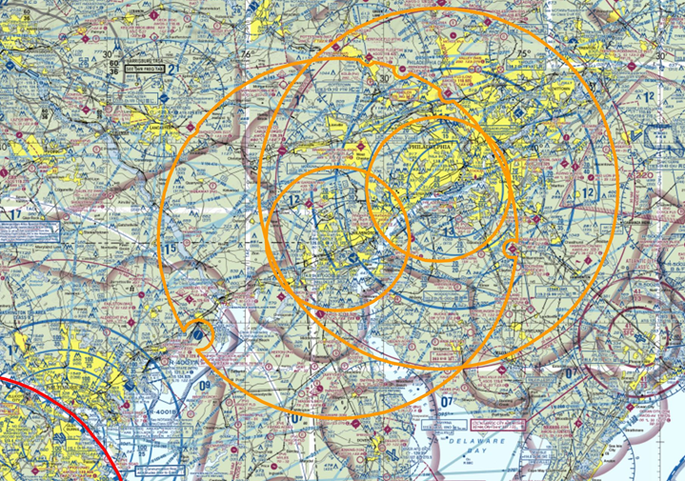

**Tips for Temporary Flight Restrictions (TFR) and Special Use Airspace**

***#1***

**REASON GA AIRCRAFT ARE INTERCEPTED:**

***Entering restricted airspace and not talking to ATC***

*3*

**KEYS TO SUCCESS**

  PLAN: Check TFRs at [http://TFR.FAA.GOV,](http://TFR.FAA.GOV/) call FSS



  TALK: to Air Traffic Control and monitor Guard (VHF 121.5)

  SQUAWK: assigned discrete transponder code

**NORAD / FAA INTERCEPT PROCEDURES**

**FLIGHT PLANNING**

* Review TFRs: [http://tfr.faa.gov](http://tfr.faa.gov/)

(Nat’l Security TFRs on Twitter: @VIP_TFR)

* Review NOTAMS:

https://pilotweb.nas.faa.gov/PilotWeb/ or https://notams.aim.faa.gov/notamSearch

… or get both TFRs and NOTAMs plus route weather and route brief by calling

1-800-WX-BRIEF (www.1800wxbrief.com)

* Review Special Use Airspace along route:

**PLANNING REFERENCES**

* Review Air Defense

**Intercept Procedures**

* Typically two fighters approach from the stern -- you may only see one
* Fighter rocks wings to signal intercept
* Fighter responsible for safe separation

**Your Actions**

* Remain predictable – Altitude, heading, airspeed, don’t descend
* Acknowledge fighter with wing rock
* Talk to ATC
* Talk to fighter on 121.5

**Post Intercept**

* Comply with instructions
* Land where directed

**DAY INTERCEPT SIGNALS**

**NIGHT INTERCEPT SIGNALS**

Identification Zone (ADIZ) procedures if flying into

**\*FLY THIS WAY**

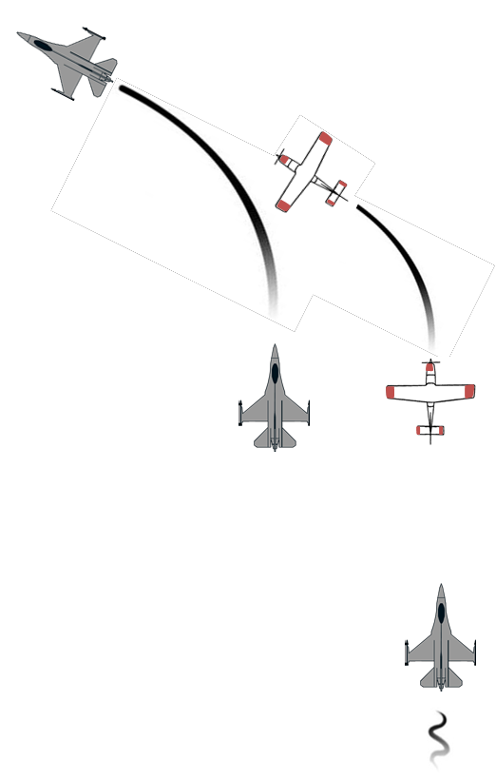

U.S. from abroad: <http://www.faa.gov/>

air_traffic/publications/ us_restrictions/airspace/ #adiz

* Review Washington D.C. Special Flight Rules Area

https://sua.faa.gov or [http://www.seeandavoid.org](http://www.seeandavoid.org/)

* + File a flight plan—IFR, VFR, DVFR, SVFR
  + Update GPS / iPad / Electronic Apps

**DURING FLIGHT**

* + Activate flight plan (prior to entering TFR)
  + IFR or flight following w/discrete squawk
  + Monitor 121.5 on back-up radio (if able)
  + Get TFR updates from FSS (1-800-WX-BRIEF)

(SFRA) procedures if flying within 60 nm of

KDCA: (Course ALC-405)

https://faasafety.gov

**These procedures describe a typical Security TFR. Check published TFR for any unique procedures.**

VFR

On a flight plan squawking discrete code and talking to ATC

IFR or VFR landing On a flight plan squawking discrete

code and talking to ATC

VFR not on a flight plan,

no radio contact, squawking 1200 STAY OUT!

30 NM radius

10 NM radius

INSIDE THE TFR:

DO NOT SQUAWK 1200 DO NOT CANCEL IFR

|  |  |
| --- | --- |
| Interceptor Signals | Meaning |
| Fighter slow turn to desired heading | *FLY THIS WAY |
| Fighter abrupt turn across nose  to desired heading and may dispense flares | WARNING: TURN NOW (DIRECTION OF FIGHTER) |
| Fighter circles airport, lowers landing gear, overflies runway in direction of landing | LAND HERE |

IFR

On a flight plan squawking discrete code and talking to ATC

|  |  |  |  |
| --- | --- | --- | --- |
| Interceptor Signals | Meaning | Your Signal | Meaning |
| Flash navigation lights | I will comply |
| Flash navigation lights | You have been intercepted |
| Turn on landing light | I will land |
| Turn on landing lights | Land here |
| Flash landing light | Airport inadequate |
| **For more intercept information, reference the Aeronautical Information Manual 5−6−2 Interception Procedures:** [**http://www.faa.gov/air_traffic/**](http://www.faa.gov/air_traffic/)  **publications/#manuals** | |
| Flash all lights regular | Can not comply |
| Flash all lights irregular | Distress |

IFR or VFR departing On a flight plan squawking discrete code and talking to ATC

North American Aerospace Defense Command (NORAD)

Get this kneeboard and more at: [www.NORAD.mil/GeneralAviation](http://www.NORAD.mil/GeneralAviation)

0816