Fuel Monitoring
Slides | Script
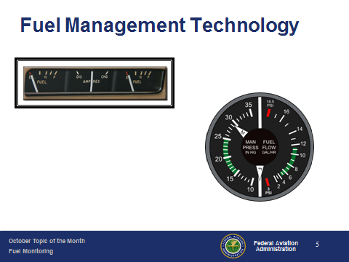 | Slide 5  Improvements on basic fuel indicators put fuel quantity information on the instrument panel.  Later, fuel flow information became available. (Next Slide)
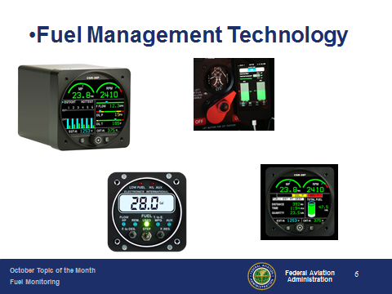 | Slide 6  Today there are a host of technologies that provide fuel quantity, fuel flow, time and even distance to fuel exhaustion – all on one instrument. (Next Slide)
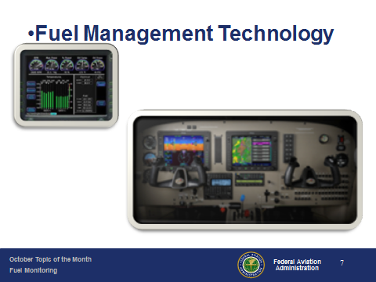 | Slide 7  And at the top of the market are integrated flight displays that compute your fuel usage and range to the ounce and mile.  (Next Slide)  .
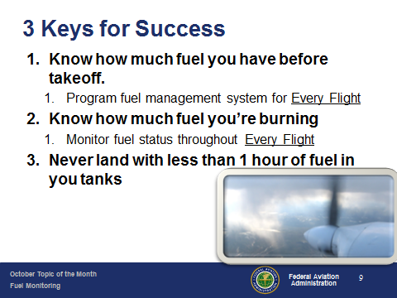 | Slide 9  But all that technology won’t help you if you don’t use it or you try to play it too close. Every year there are dozens of fuel exhaustion accidents that occur in sight of the destination airport. Here are 3 keys for Success:  - Whether you’re “sticking the tanks” or relying on cutting edge fuel management software, know how much fuel you have on board before each takeoff. Make sure you program your fuel management system with accurate information before Every Flight  - Know how much fuel you plan to burn and how much fuel you’re burning. If you don’t have on board equipment to answer this question then calculate your fuel burn in flight and confirm your calculations each time you refuel. Not only will you have confidence in your fuel planning but you can often spot leaks or small problems before they become big ones just by verifying how much fuel it took for each flight.  - Finally, many pilots have a policy to never land with less than one hour’s fuel in the tanks. This will exceed any regulatory reserve fuel requirements and you’ll never be anxious about pushing your fuel. (Next Slide)
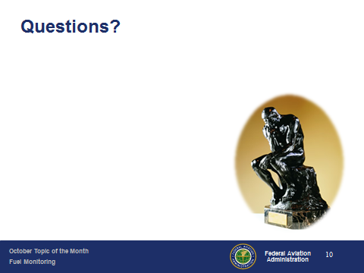 | Slide 10  Presentation Note: You may wish to provide your contact information and main FSDO phone number here. Modify with your information or leave blank. (Next Slide)
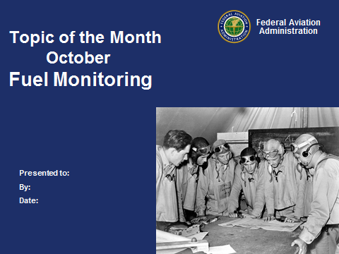 | Slide 11  The End

