Fuel Monitoring
Abstract: Lasting 10 to 15 minutes, this presentation acquaints the audience with the need to conduct fuel monitoring during every flight and encourages pilots to acquire and use fuel monitoring technology.
Format: Information Briefing - Power Point presentation
Required Personnel – FAASTeam Program Manager or designated FAASTeam Rep (s)
Optional Personnel – CFIs and DPEs who can speak on the benefits of fuel monitoring
AFS 850 Support:
In addition to this guidance document, a Power Point presentation that supports the program is provided. FPMs and presenters are encouraged tol customize this presentation to reflect each individual program.

Appendix I – Equipment and Staging
Equipment:
- Projection Screen & Video Projector suitable for expected audience
  - Remote computer/projector control available at lectern or presenter location
    - In lieu of remote – detail a Rep to computer/projector control.
- Presentation Computer
  - Note: It is strongly suggested that the entire program reside on this computer.
- Back up Projector/Computer/Media as available.
- PA system suitable for expected audience
  - Microphones for Moderator and Panel
    - Optional Microphone (s) for audience
- Lectern (optional)
Staging:
- Arrange the projection screen for maximum visibility from the audience.
- Equip with PA microphones
- Place Lectern to one side of screen. This will be used by presenters and moderator

Slides | Script
 | Slide 1  Presentation Note: This is the title slide for Fuel Monitoring.  Presentation notes (stage direction and presentation suggestions) will be preceded by a Bold header: the notes themselves will be in Italic fonts.  Program control instructions will be in bold fonts and look like this: (Click) for building information within a slide; or this: (Next Slide) for slide advance.  Some slides contain background information that supports the concepts presented in the program.  Background information will always appear last and will be preceded by a bold Background: identification.  We have included a script of suggested dialog with each slide. Presenters may read the script or modify it to suit their own presentation style.  The production team hope you and your audience will enjoy the show. Break a leg! (Next Slide)
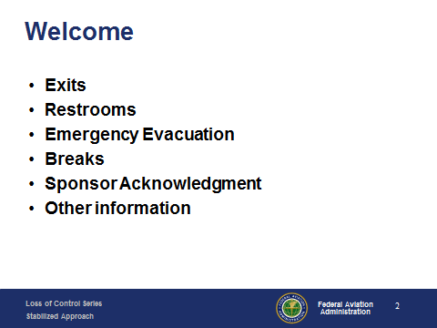 | Slide 2  Presentation Note: Here’s where you can discuss venue logistics, acknowledge sponsors, and deliver other information you want your audience to know in the beginning.  You can add slides after this one to fit your situation. (Next Slide)
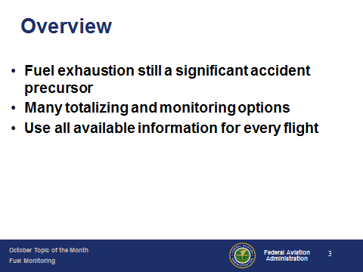 | Slide 3  We want to take just a few minutes to talk about fuel management. It’s still a significant general aviation accident precursor and a causal factor in  Nearly 10% of all GA accidents.  Fortunately today there are a host of affordable fuel monitoring and totalizing technologies available to GA pilots.  We want to encourage their use on every flight.  Presentation Note: If you’ll be discussing additional items, add them to this list (Next Slide)
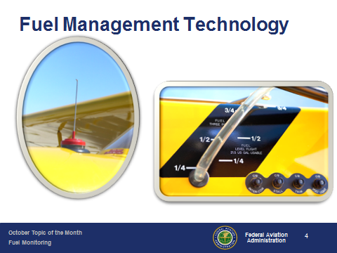 | Slide 4  The most rudimentary fuel gauges are definitely low tech and fuel computations take place in the pilots’ head. (Next Slide)
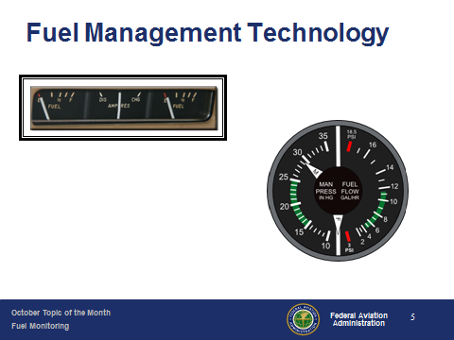 | Slide 5  Improvements on basic fuel indicators put fuel quantity information on the instrument panel.  Later, fuel flow information became available. (Next Slide)
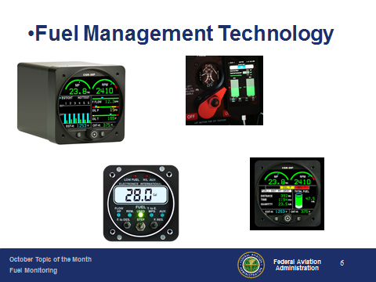 | Slide 6  Today there are a host of technologies that provide fuel quantity, fuel flow, time and even distance to fuel exhaustion – all on one instrument. (Next Slide)
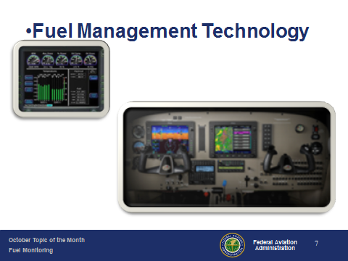 | Slide 7  And at the top of the market are integrated flight displays that compute your fuel usage and range to the ounce and mile.  (Next Slide)  .
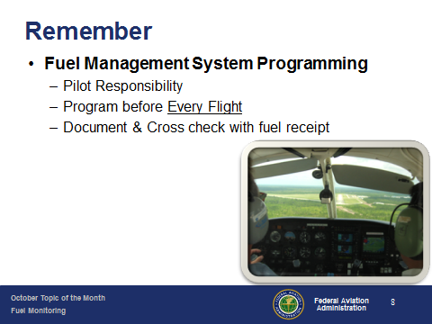 | Slide 8  Remember: All fuel management systems have to start with a known quantity of fuel. It’s up to pilots to confirm this starting point by accurately programming their fuel management equipment before Every Flight! Document your fuel usage for each flight and cross check it against your fuel receipts. If your calculations are correct and your fuel management system’s working properly you should be within ounces of agreement. If not – be sure to find out why before your next flight.  (Next Slide)
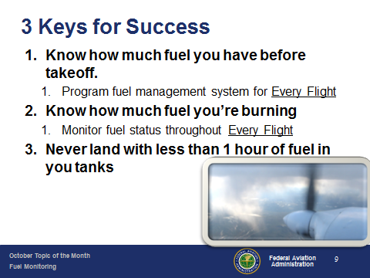 | Slide 9  But all that technology won’t help you if you don’t use it or you try to play it too close. Every year there are dozens of fuel exhaustion accidents that occur in sight of the destination airport. Here are 3 keys for Success:  - Whether you’re “sticking the tanks” or relying on cutting edge fuel management software, know how much fuel you have on board before each takeoff. Make sure you program your fuel management system with accurate information before Every Flight  - Know how much fuel you plan to burn and how much fuel you’re burning. If you don’t have on board equipment to answer this question then calculate your fuel burn in flight and confirm your calculations each time you refuel. Not only will you have confidence in your fuel planning but you can often spot leaks or small problems before they become big ones just by verifying how much fuel it took for each flight.  - Finally, many pilots have a policy to never land with less than one hour’s fuel in the tanks. This will exceed any regulatory reserve fuel requirements and you’ll never be anxious about pushing your fuel. (Next Slide)
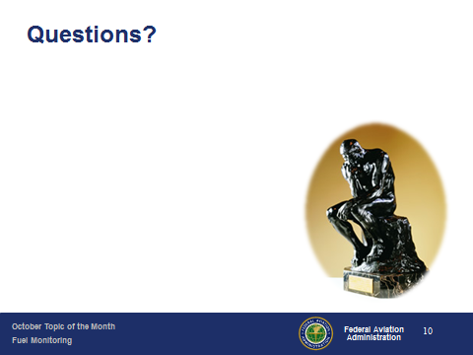 | Slide 10  Presentation Note: You may wish to provide your contact information and main FSDO phone number here. Modify with your information or leave blank. (Next Slide)
Slide 11
The End

