|  |  |  |
| --- | --- | --- |
|  | **FAA Branding:**  **How to Use FAA PowerPoint Templates**  **How to Modify the Template Slide Master** |  |

**By**

**William J. Doyle, Jr., CFI A&I, AGI, IGI**

**PHL FSDO FAAST Rep**

**April 10, 2015**

**Introduction**

In early 2010, a technician at the FAA’s Eastern Region HQ, gave me three FAA PowerPoint templates:

* FAA_slide_template_bluecover_whitebackground.pptx
  + This is the template that I use for my FAA Safety Seminars. It uses a white background on each of the slides in the body of the presentation. It is available at the link below.
    - <http://williamjdoylejr.net/FAAST/FAA_Template/FAA_slide_template_bluecover_whitebackground.ppt>
  + This template will be the model used for modification of the slide master.
* FAA_slide_template_bluecover_bluebackground.pptx
  + This template uses a blue background on each of the slides in the body of the presentation. It is available at the link below.
    - <http://williamjdoylejr.net/FAAST/FAA_Template/FAA_slide_template_bluecover_bluebackground.ppt>
  + Printing a presentation built from this template will consume a great deal of ink or toner.
* FAA_slide_template_blackandwhite.pptx
  + This template uses a white background with black and blue text on all of the slides in the presentation. It is available at the link below.
    - <http://williamjdoylejr.net/FAAST/FAA_Template/FAA_slide_template_blackandwhite.ppt>

**FAA_slide_template_bluecover_whitebackground.pptx – Presentation Overview**

This template uses a blue cover or title slide. The slides in the body of the presentation use a white background.

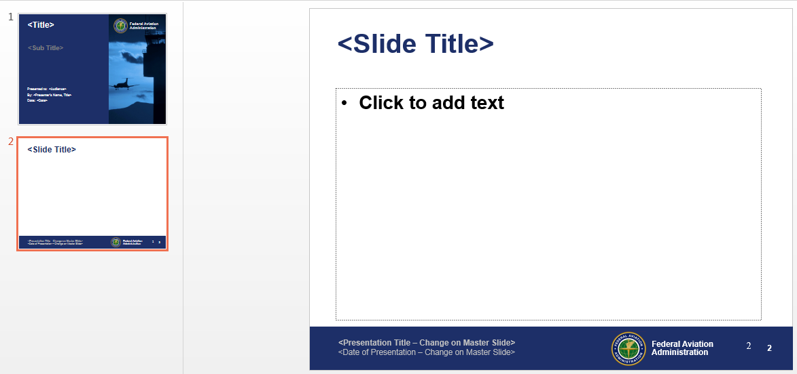

**FAA_slide_template_bluecover_bluebackground.pptx – Presentation Overview**

This template uses a blue cover or title slide. The slides in the body of the presentation use a blue background.

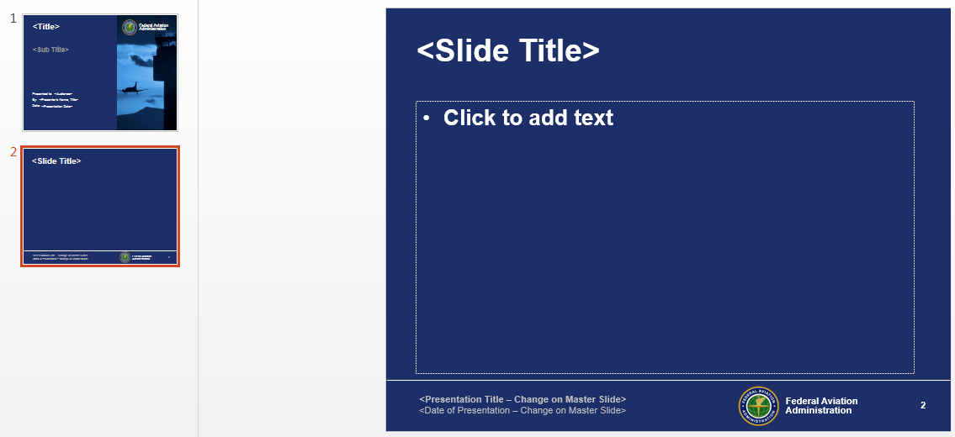

**FAA_slide_template_blackandwhite – Presentation Overview**

This template uses a blue cover or title slide. The slides in the body of the presentation use a blue background.

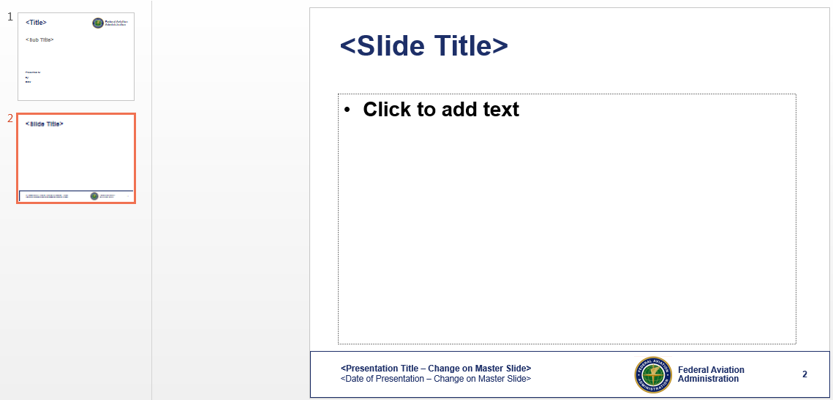

**FAA_slide_template_bluecover_whitebackground.pptx – Slide Master**

* Click the menu name View.
* Click Slide Master.
* This will take you into the Slide Master.
* Any changes you make here will apply to the eleven (11) subordinate or related slide layouts shown below the Slide Master.

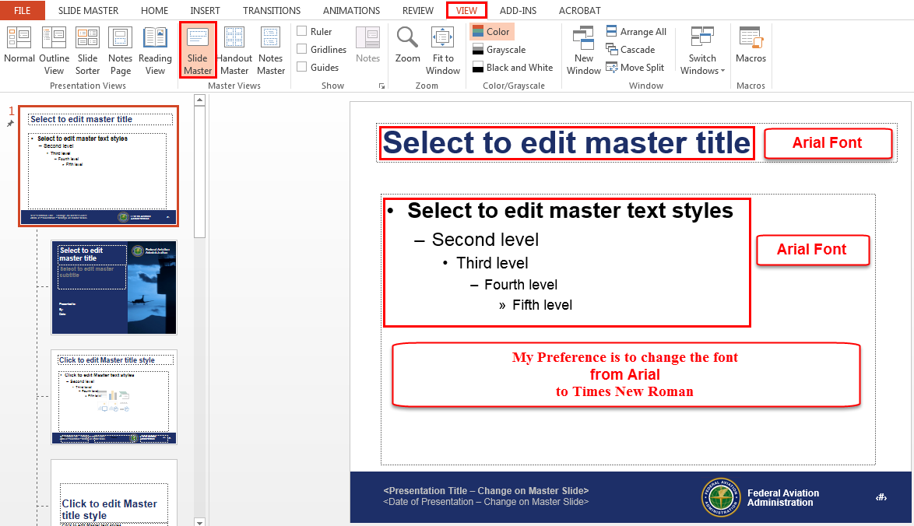

The image below is a footer to the Slide Master. It contains the following:

* Presentation Title – change to reflect a short title for your presentation, e.g. “FAA Branding by Bill Doyle, CFI A&I, PHL FSDO FAAST Rep.” You should change it each time you use the template to build a presentation.
* Presentation Date – suggest using the fiscal year instead of the specific date for each presentation, e.g. “FY 2015 - 2016.”
* Inserted Page Number does not change.

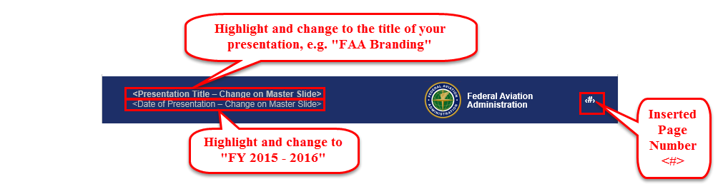

The image below reflects the changes made to the Slide Master.

Selecting Times New Roman did not automatically carry to the “footer.”

* Presentation Title – needed to be changed from Arial to Times New Roman.
* Presentation Date – needed to be changed from Arial to Times New Roman.

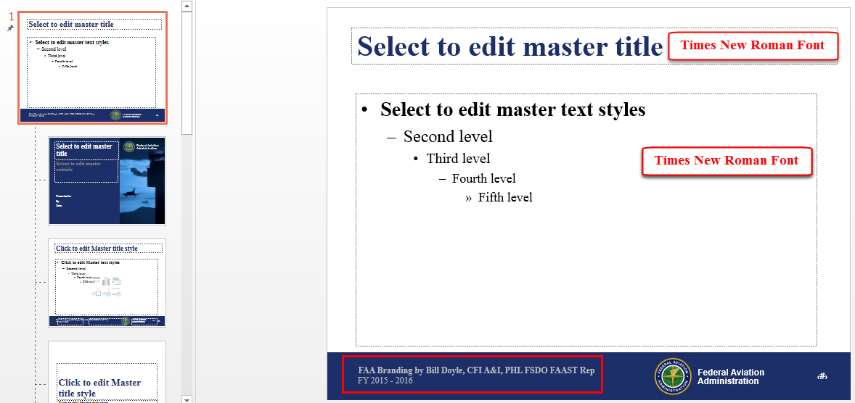

Click on the Slide Layout for the Title Slide

* Title and Subtitle use Times New Roman font from the Slide Master
* Following items need to be changed from Arial to Times New Roman
  + Presented to:
  + By:
  + Date:

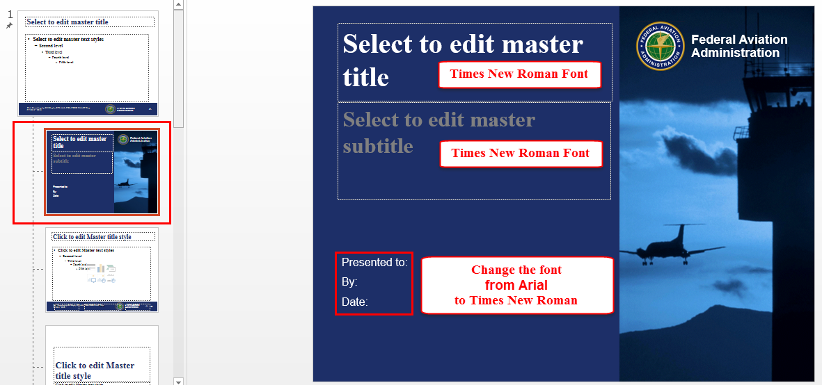

There is a duplicate page number inserted on the ten (10) Slide Layouts following the Title Slide Layout. This problem does not exist in the other two templates.

* Highlight this as indicated below
* Press the Delete key

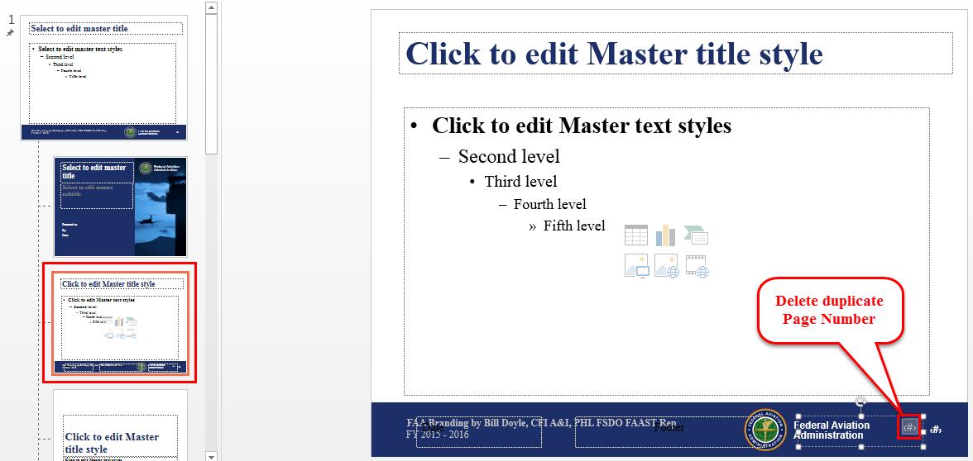

When done, click the “Close Master View” button.

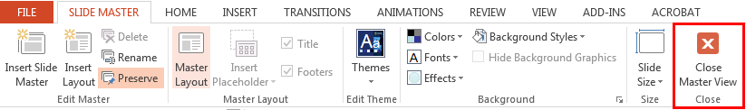

Click the menu name “File,” then click on “Save As.”

* Suggest appending your initials to the original file name as shown below.
  + FAA_slide_template_bluecover_whitebackground_WJD.pptx

**Finalizing the Title Slide**

Consider the example below:

* <Title> - Something catchy like “Don’t Get LOC-ed Out!”
* <Sub Title> - Something serious like “How to Recognize and Avoid Loss of Control”
* Presented to: FAA Safety Seminar Attendees
* By: - Your Name, FAA CFI certificate (if held), PHL FSDO FAAST Rep
* Date: FY 2015 – 2016

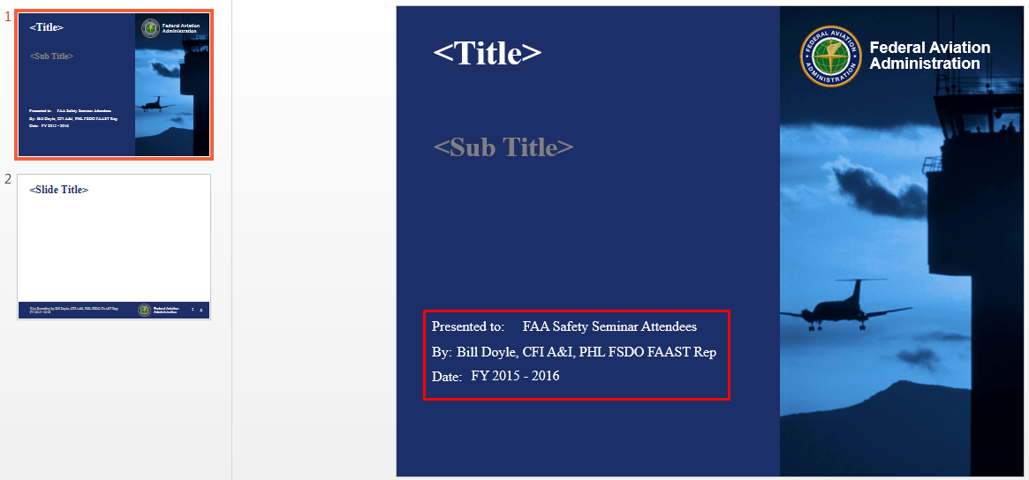

**How to Import Slides from “Un-branded” Presentations**

Display your template in Slide Sorter mode.

* Click the menu name “View.”
* Click the “Slide Sorter” button.

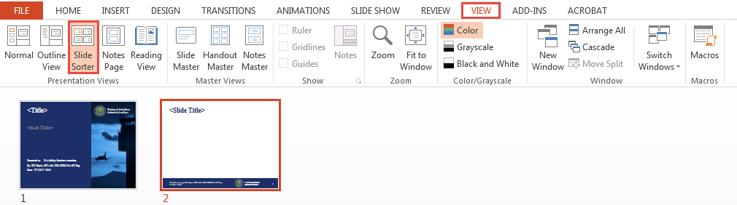

Open your “un-branded” presentation.

Display your “un-branded” presentation in Slide Sorter mode.

* Click the menu name “View.”
* Click the “Slide Sorter” button.
* Select slides 2 through 14
* Press Ctrl/c to copy the selected slides

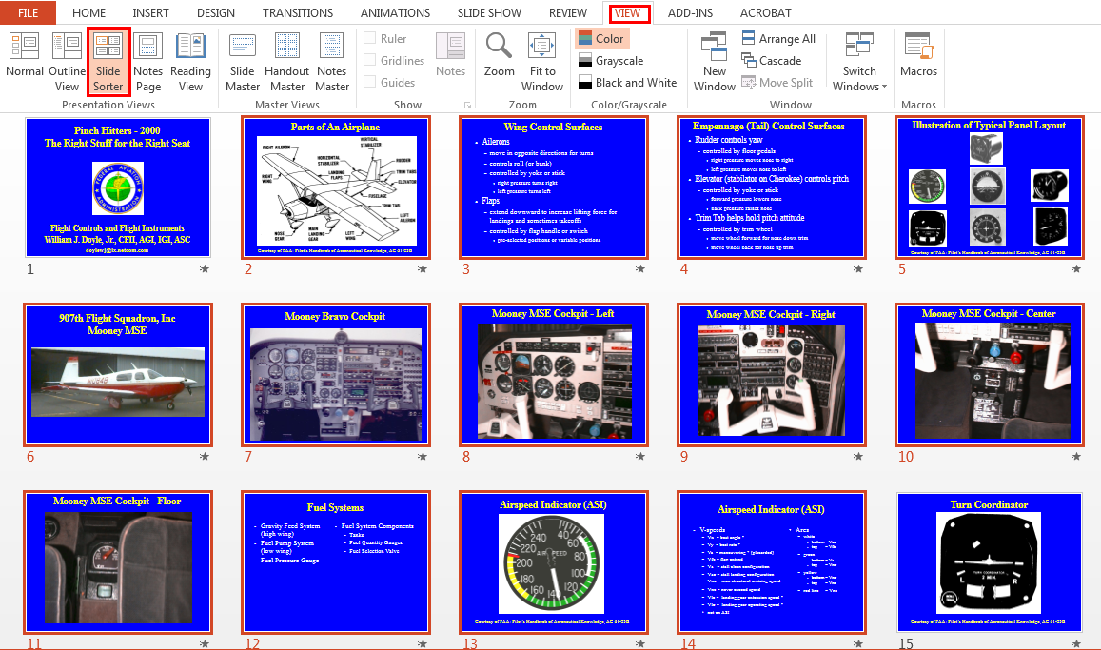

**Switch to your template**

* Click after slide #2 to put the insertion point there
* Press Ctrl/v to paste the copied slides

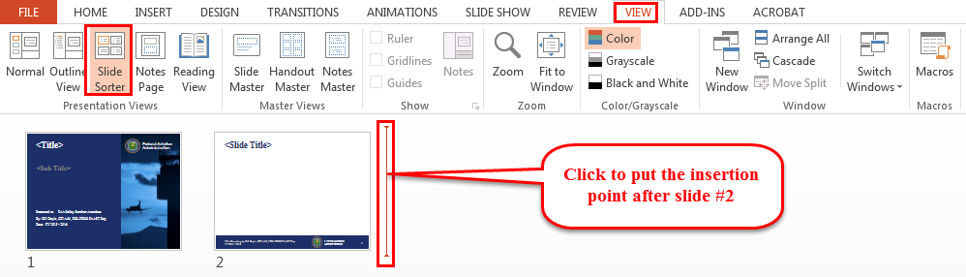

After pasting the slides from your “un-branded” presentation, your template should look something like the image below.

* Review each of your pasted slides for alignment of images and footnotes.
* “Tweak” as necessary.

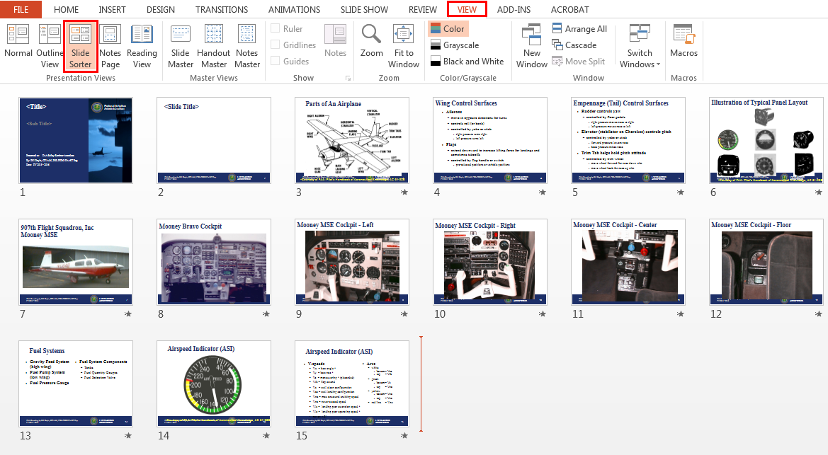

Click the menu name “File,” then click on “Save As.”

* Save under a new name that is appropriate to the presentation you are building.

**Reference Materials**

* FAA Branding Tutorial
  + <http://williamjdoylejr.net/FAAST/FAA_Branding/FAA_Branding_A_How_To.pdf>
* FAA Model Template
  + <http://williamjdoylejr.net/FAAST/FAA_Branding/FAA_slide_template_bluecover_whitebackground.ppt>
* FAA Model Template – Updated in Tutorial
  + <http://williamjdoylejr.net/FAAST/FAA_Branding/FAA_slide_template_bluecover_whitebackground_WJD.ppt>
* “Un-branded” PowerPoint for use in Tutorial
  + <http://williamjdoylejr.net/FAAST/FAA_Branding/Doyle_Pinch_Hitters_Right_Stuff_for_the_Right_Seat.ppt>
* “Branded” PowerPoint created in Tutorial
  + <http://williamjdoylejr.net/FAAST/FAA_Branding/FAA_Branding_Example.ppt>